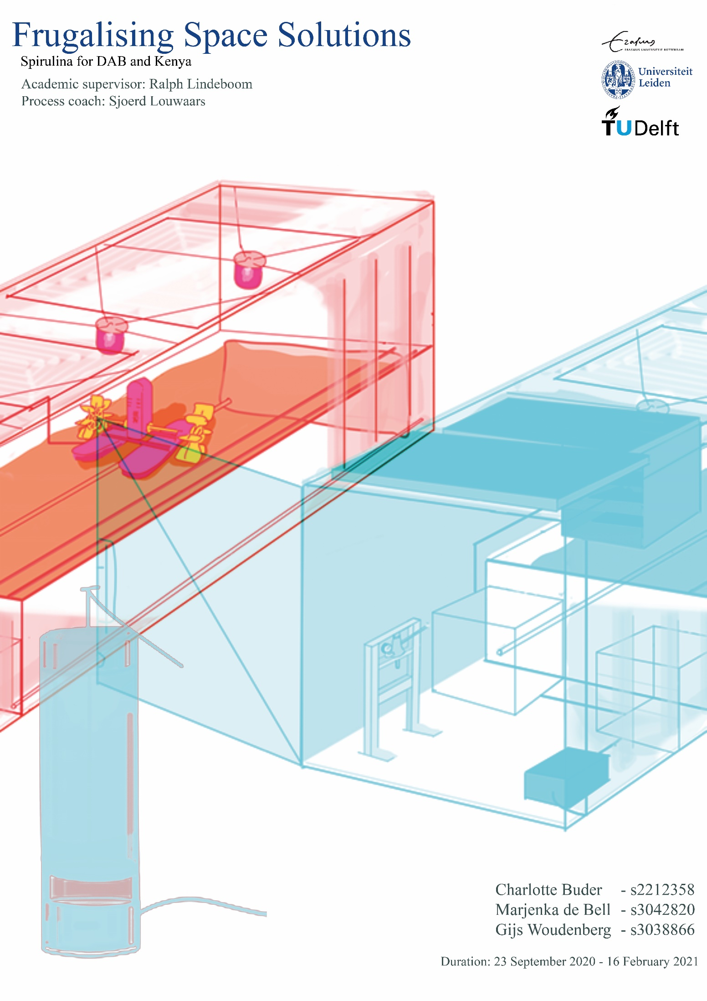

Executive Summary

This report was commissioned to give an overview of our internship at SEMiLLA in collaboration with the DAB Lab as part of our minor “Frugal Innovation”. To intensify the frugality of the project, two main focuses were created: a focus on the DAB lab and a focus on the Global South.

The main goals stated by the DAB lab were attracting young professionals and students to their innovation hub. The conducted research indicated that green branding and corporate storytelling could help to increase the attractiveness of the building. Therefore, a cylinder-shaped Spirulina (microalgae) farm called “Visulina” was invented, which incorporates both approaches. First, Visulina contributes to the circularity of the building because it absorbs the CO2 of one person per day. Second, Visulina incorporates frugalised technology used during long-term space missions, which contributes to a marketable story.

The Global South project was implemented in Kenya, whereby the conducted social study demonstrated a strong need for nutritional food supplements in malnourished children under 5, which makes them the main beneficiary. The macro- and micronutrients lacking in many preschool aged children’s diets are found in Spirulina and thus the daily intake of one to three tablespoons of the dried microalgae powder were found to improve public health significantly. Compared to other proteins, Spirulina was found to be the most resource-efficient. Fisheries have adequate initial equipment such as water and knowledge to maintain a Spirulina farm, thus they function as our main clients. The developed product is a Spirulina farm built out of a shipping container holding 17,000 - 19,000 litres of water that incorporates the different stages of Spirulina powder production such as growing the Spirulina, harvesting and drying it. Furthermore, the farm accounts for high-quality content because of its covered design and vigorous testing by employed university students. The farm is compact and cheap, costing only €5,000. Research indicated that around 5% of fish farmers (~316) would buy the Spirulina farm, which means each producer has to produce 45kg of Spirulina a year to satisfy the calculated customer need. The financial plan indicates a break-even point of 1.87 years when selling the product at a price of €70 per kg, which makes it the cheapest product for its quality standards on the market.

Potential risks and limitations include the competition with other Spirulina projects giving the product to specific demographic groups for free. Furthermore, algae has a very negative perception ín Kenya, which could be a risk to selling our product. The design needs to be tested in practice in the future to draw serious conclusions about its functionality and stability in the local climate.

Table of contents

Chapter 1: Introduction 5
1.1 Description, host organization and initiative 5
1.2 Description of the overall research program/project 5
1.3 Team members 5
Chapter 2: DAB lab case 7
2.1. Social Study 7
2.1.1. Problem Analysis and solution fit 7
2.1.2. Green branding approach 7
2.1.3. Corporate Storytelling approach 7
2.1.4. Validation through student survey 8
2.1.5. Spirulina Perception in the Netherlands 9
2.2. Design Visulina 11
2.2.1. Circularity 13
2.2.2. Design Progression 13
2.2.2.1. Initial plan 13
2.2.2.2. Final plan 15
2.2.2.3. Build-plan 16
2.3. Business Case 18
2.3.1. Competitors 18
2.3.2. Attracting people 19
2.3.3. Marketing 19
2.4. Conclusion 21
Chapter 3: Social Study 22
3.1. Connection Kenya and the Netherlands 22
3.2. Problem Analysis Kenya 22
3.2.1. Beneficiary 1: Fisheries 22
3.2.2. Beneficiary 2: Children under 5 23
3.2.3. Solution Fit Spirulina 24
3.3. Potential - Urban Food Deserts 25
3.4. Local Conditions and Spirulina Growth 25
3.5. Consumers and Distribution Channels of Spirulina 26

Chapter 4: Business Case 27
4.1. Spirulina Market 27
4.2. Competitors 27
4.3. Kenyan Spirulina production 29
4.4. Porter’s 5 forces 29
4.5. Business phases 31

Chapter 5: Design 33
5.1. Spirulina Farming 34
5.2. Modifications to the Container 35
5.3. Components 36
5.4. Differentiation 37 5.5. Testing Design 37
5.6. Circularity 38
5.7. Limitations 39

Chapter 6: Financial plan 40
6.1. Legal requirements 40
6.2. Break-even analysis 40
6.2.1. Costs and Revenues 40
6.2.2. Carbon Credits 40
6.3. Marketing 41
6.4. Evaluation: SWOT 42

Chapter 7: Conclusion 43
7.1. Risk Assessment 43
7.2. Global South Project 43
7.3. Recommendations 44
7.4. Reflection 44

Appendix 45
Bibliography 49

Chapter 1: Introduction

Description host organization and initiative
SEMiLLA IPStar is an agency developing space technology for circular systems on Earth. It is the technological transfer member of MELiSSA, which is a space research agency created and run by the European Space Agency. SEMiLLA researches artificial closed ecosystems used in space and tries to find niche locations on Earth where these could be applicable. This could include resource-scarce environments, but also environments, where high-tech solutions are applicable and affordable. They work with water treatment, waste management, air quality, controlled food production, and biosafety among others. The organization has created the SEMiLLA Circular Economy Hub to share knowledge and ideas about sustainable livelihoods. At the wastewater treatment facility in Koningshoeve in the Netherlands SEMiLLA has demonstrated how a successful feasibility study could lead to the implementation of space-inspired technology. Other projects include wastewater treatment projects (created by the SEMiLLA Sanitation team) and feasibility studies in the Netherlands but also in other countries such as Kenya.

Description of the overall research program/project
In our case, SEMiLLA is establishing a cooperation with the DAB lab (Delta Agrifood Business Lab) in Bergen Op Zoom. SEMiLLA will execute a feasibility study with the aim to define the most suitable Space-inspired technology to implement in the DAB lab. We are thus working together with SEMiLLA and the DAB lab.
Team members
Our team, called the ‘Interdisciplinary Space Students’ because we are all studying different subjects, will try to use MELiSSA space technology to create a small farming container.
Charlotte is a third year student from Leiden University College, majoring in “Governance, Economics and Development”. Her contribution to the internship will mainly be the social science-related part of the field assignment, because that fits best with her study program. This means she will be checking up on the chosen locations, she will be trying to analyse the social environment of that location and see if the product is really needed. The feasibility of implementing the product in a particular location will play a role, which will be done through analysing the local business culture, possible crime rates, possible dangers etc. She will try to detect the need for the product and will try to talk to locals in order to find out if they would be willing to make use of the product taking into account time constraints, cultural constraints and personal circumstances. In Bergen Op Zoom, she will try to validate the assumption that more young people would be attracted to the lab due to an international partner and will try to find out what young people want so the DAB lab gets more young input. For the cubicle that will be implemented in the DAB lab she will be developing surveys and interviews to see if people would be willing to eat agricultural products grown in a circular economy (meaning food grown with the help of waste products).
Gijs is a fourth year industrial design engineering student at TU Delft, his role in the team will be design focused. He thinks this means that he will be looking at a lot of the functionality of what the team will be making. This includes looking at the feasibility of ideas making models, sketching, basic stress calculations. But also lead group brainstorms and look at the usability of what we make. He will think of tests for the product if necessary and make sure we can improve upon those tests. He will be helping his group members a lot so he can learn how to work in a team with other disciplines and how to make best use of that. He will set up the Scrum or Lean working method that we will be trying out during the internship. The bulk of his work will be in coming up and working out design solutions that will make the product simple, usable, cheap and suitable to the BOP market. Just like the other group members he will also do BOP and DAB research.

Marjenka is a third year International Business Administration student from the Erasmus University Rotterdam, who did an earlier minor on the ‘Moral Limits of Markets’. She will mainly work on the business plan during this assignment. Together with Charlotte, she will work on discovering the market demand and supply, but mostly working on the supply side by analysing competitors, and to see if people would buy our product. She will have to analyse how much the DAB lab would be willing to spend on our project, and to what degree this will be similar in the Global South. Additionally, she will design a marketing strategy for the product to penetrate the market, and use knowledge from her main study on, among others, SWOT analysis, and the frugal Business Model Canvas to form a coherent strategic business plan for our product. Lastly, she will either adapt or design our business model so the concept can be applied on a modular, replicable scale, so our product can be potentially be sold in more (developing) countries.

Chapter 2: DAB lab case
Social Study

Problem Analysis and Solution Fit
The DAB lab located in Bergen op Zoom has a problem of not attracting enough young professionals to their building according to the DAB lab manager Anja Hessels. Its main goal is to rent out the space within the building to agri-food companies and young people to create a hub for sharing ideas and knowledge about the agri-food business sector. To reach this goal, the DAB lab managers were thinking of increasing the building’s sustainability to make it more attractive to the younger generation such as high school and university students, young adults and start-ups. We have thus produced the idea of installing a tank within the building to grow and harvest Spirulina with the help of technology used during long-term space missions. Spirulina was described as one of “the greatest superfoods on earth” by the WHO (Khan et al., 2005) and NASA considers it to be an excellent compact food for space travel (Khan et al., 2005). The tank we are installing uses CO2 from the air within the buildings and portrays an interesting installation, which people can learn from. It thus leads to a more circular system within the DAB lab while also educating people on space technologies.
DAB representative for western context

“Green Branding” Approach
Incorporating green branding into a company has many advantages, such as appealing to their customers (Bathmanathan and Hironaka, 2016). The increase in consumer awareness and preference for environmentally friendly branded products has been proven by various studies (Bathmanathan and Hironaka, 2016), which leads to the assumption that creating a more sustainable agri-food hub will attract more companies because they know they can sell more products through green branding. Furthermore, the younger generations have an increased awareness of environmental problems (Yamane and Kaneko, 2021), which would make a sustainable building more attractive to them. Many successful innovation hubs, in for example Sweden, use their green image to promote themselves (for example Piteå Science Park, Science Park Borås etc.), which could be implemented by the DAB lab in the same manner. Additionally, our target group, namely the younger generation, is more aware of green branding and more likely to change their consumer choices according to it (Yamane and Kaneko, 2021). To confirm these assumptions, we were planning to analyse a questionnaire directed at the companies within the DAB lab and conducting interviews with employees working in the building, but never got responses.

Corporate Storytelling approach
To make the DAB lab building more attractive, we investigated the art of corporate storytelling as a means to improve external reputation. Thereby, the term corporate storytelling refers to the process of creating a message that conveys a new point of view or strengthens an opinion by using narration about the organization, future visions and goals, people and work itself (Gill, 2011). This motivates people and makes the company itself or the product they are selling more memorable (Gill, 2011). Stories communicate an organization’s values and goals, whereby they appeal to culturally diverse audiences (Gill, 2011). To integrate this concept into our project, we are trying to establish a connection between the DAB lab and Kenya. Thereby, we have the chance to integrate the intercultural communication skills we have been learning about in our minor on Frugal Innovation. With the creation of a similar product in both locations a story of a similar goal regarding sustainability and circularity is conveyed. The story would include a mix of anecdotes and facts about space technology, sustainability and the product in Kenya.

Validation through Student Survey
To validate the assumptions that a green image and a story makes the building more attractive for young people, we conducted a survey targeted at high school and university students, to which 42 respondents aged 17-22 answered. More than half of the respondents were not at all or not interested in the agri-food business sector and over 80% are not interested in working in the sector in the future. This could be explained by the fact that two thirds of the respondents assessed their knowledge about the agri-food business sector as lower than and including four on a scale from 1-10. When looking at the technique of corporate storytelling, over half of the respondents indicate that they would be moderately to strongly interested in learning about sustainable innovations in the Global South and over one third would be interested in connecting to students their own age in the same area. This means for us, that the corporate story telling method could work and the DAB lab is advised to establish a connection with a location in the Global South, whereby they could create online live events with students from both the Netherlands and the Global South or a live camera that compares the Spirulina growth in both a location in Kenya and the DAB lab. The survey gives a clear indication that by exhibiting sustainable space technology the interest in visiting the DAB lab would grow significantly and with the chance of consuming food produced by that same technology it would increase even more. Young people would be willing to spend around 30-60 minutes on average in the DAB lab if it exhibited technology used during long-term space missions. These results were also verified by three students from the high school in Bergen Op Zoom we talked to during our internship. Concretely, this means that the Spirulina project we are working on would attract more young people to the Lab if they expand it further and add explanations to the construction. Additionally, it would be interesting to give out samples of dried Spirulina powder or to cook something containing the microalgae and presenting it as samples. The following paragraph will explain what these samples should look like to increase the chance of their social acceptance.
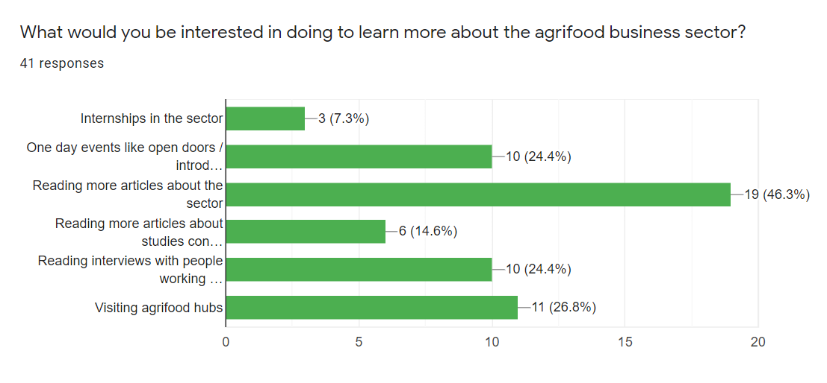
Figure 1.: Student Survey
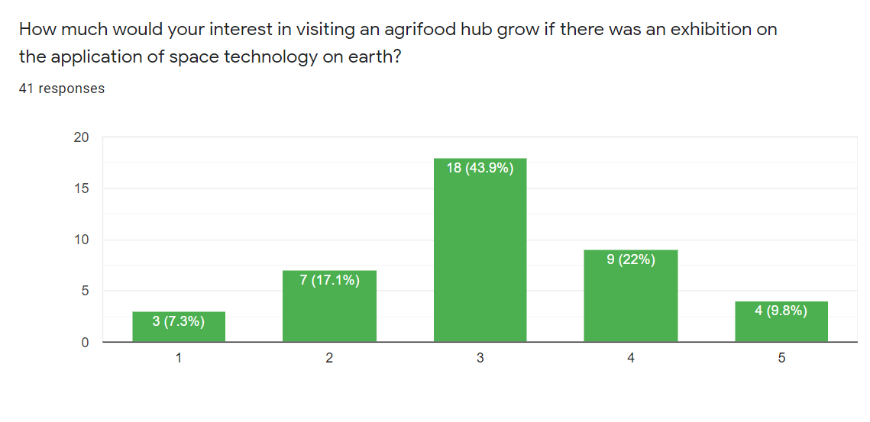
Figure 2.: Student Survey
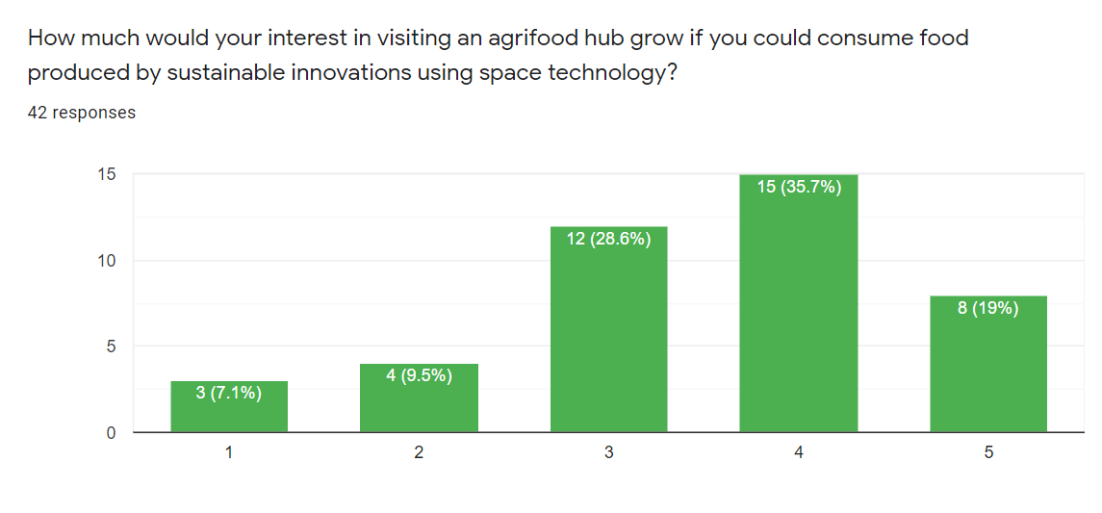
Figure 3.: Student Survey

Spirulina perception in the Netherlands
Within the Netherlands, the already existing market for Spirulina as a plant food supplement signifies that the microalgae is accepted as a useful contribution to the diet in some demographics of the country. In a study conducted in 2018, Spirulina is ranked as the fifth most consumed Plant Food Supplement in the Netherlands (Jeurissen et al., 2018). This leads us to the assumption that a device to produce Spirulina in the DAB lab would be beneficial because a certain part of the population perceives it to be a healthy contribution to their daily food intake. In a study conducted by Grahl et al. (2018), one third of the Dutch respondents knew about microalgae and 80% of those people knew about Spirulina. The acceptance for foods with Spirulina as the main protein source increased with the familiarity of the product - Spirulina pasta for example was met with a higher acceptance than Spirulina Sushi (Grahl et al., 2018). When installing the Spirulina farm inside the DAB lab, we thus have to be careful to include an explanatory sign or presentation about Spirulina and its benefits. Furthermore, if the microalgae were to be sold or sampled, it should be included in familiar dishes as to increase the chance of acceptance and future private use.

Design Visulina
The research conducted about DAB lab suggests that it is important that the design or solutions attempt to make a positive impact on the following problems:
- Make the building more attractive for young start-ups to work with.
- Make the corporation more attractive for young students and professionals in the agri-food sector.
- Make the building more eco-friendly
- Make the image of the building more eco-friendly
- Make a marketable story
Early on, the decision was made to use a Spirulina farm to improve the building. Some other ideas were explored as well (water filtering, solar energy and more) but eventually the project was expanded to the Global South (Chapter 3) . Where, according to previous research, Spirulina could make a positive impact. Because both projects would be worked on at the same time it was decided that both would be Spirulina farms.
The focus of the farm at the DAB lab would be good publicity and ways to inspire young people to work in the Dutch agrifood sector. Where our Kenyan beneficiary has a need for everything Spirulina offers, the DAB lab is more interested in the process and mechanisms of farming than using the Spirulina. Because Spirulina filters air it could also function as an air purifier.
The goal was to make a system that can be used as a smaller scale example of what impact this type of farming can have. One of the goals was to show what it takes to fixate a person's daily CO2. This is why the thanks is designed to fit that exact amount of spirulina. We wanted to make this process visible to the user and make it easy to understand and monitor. Therefore, we chose the name “Visulina”.
When the design process started, we decided to use the European Space Agency (ESA) AstroPlant kit as a basis. This system is based on Raspberry Pi modular computer parts and sensors. And has software integration that would need some tweaking because it is meant for normal plants. Later in this paper we elaborate on the requirements and modifications to the kit that are needed. The system is very modular, which is a big advantage because that allows one to make it monitorable and add all sensors needed. This way, the DAB lab can use the device to educate students coming to the building and working with the farm. It gives them an opportunity to have people work hands-on with a Spirulina farm that also looks attractive in their cafeteria.
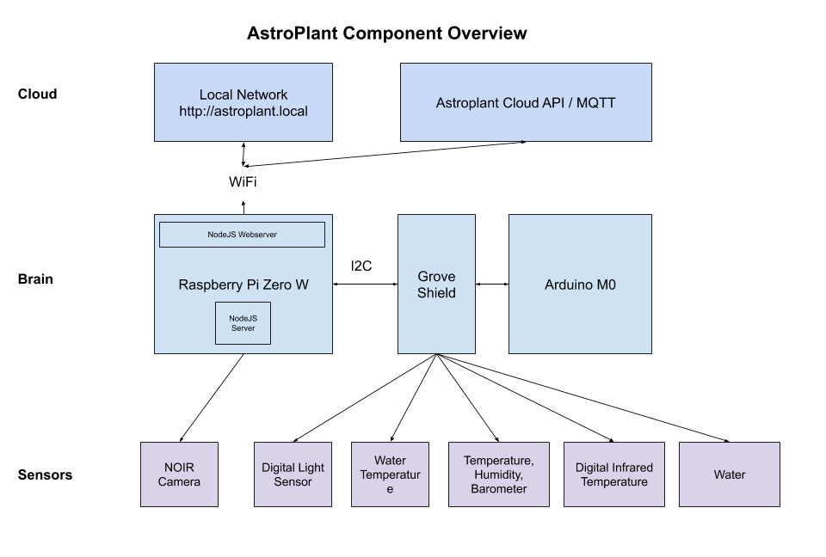
Figure 4.: AstroPlant Component Overview via the AstroPlant dev kit page on GitHub
The schematic visualization shows what the current Astroplant kit is made up of. To grow algae the kit needs some additional sensors and features. It is important for the device to monitor the CO2 levels of the water temperature, light exposure and ph. levels. It would also be possible to track the Spirulina yield once the system can be harvested by seeing the influence of moving water.
It is possible to simply buy sensors to track the CO2, temperature and ph. However, for a CO2 sensor the PH is important and has to be stable (Vernier, n.d.) to be able to correctly read off the CO2 levels. if this would be integrated in the software that would make the research done on the machine easier. Besides the sensors the water also must be heated. A normal 600 watt aquarium pump would suffice in heating the tank.
For the Visulina a water proof light is used. This is important because the light must be positioned in the cap of the device so it would not hinder the filter. This way it still lights up the system. The normal Astroplant light could also be used for an algae farm and if attached to the glass of the farm the heat sink would potentially not be necessary. Experimentation has yet to be done.
The wet (living) Spirulina is the healthiest type of Spirulina and since a drying system with an oven and press is a big investment we decided on producing fresh Spirulina . The Spirulina can be consumed in its wet form, which would be the most economically viable solution for the system. It can also be used to feed other plants or bugs.

Circularity
The DAB lab strives to make its building more energy efficient and SEMiLLA is helping with its circular space technology. The Spirulina farm could play a part in this by storing CO2 from the air. If the farm could store about the amount a person exhales in a day per day that would provide a substantial addition. But it would also be a clear representation of how much it takes per person. A person exhales approximately 1043 grams each day and in good conditions (with an optimal nitrogen concentration of 0.045 M) the CO2 consumption rate productivity were further increased to 1.58 g/L/d (Chen et al., 2013).
This means that if we want the design to filter a human's CO2 in a day the tank would need to contain approximately 660 litres. This implies the capacity of the tanks should be at least 0.66 m^3. If however you wanted to do a whole building you should dedicate a much larger space for spirulina and have air ducts that run into that space.
Possible dimensions for the tank would then be height: 170 cm radius 35 cm.
To make a system fully circular would be a task too expensive for we would have to instal water filters that are unnecessarily big for the system.
Design progression
- Initial plan
The first idea was focused on the concept of adding to the building with a device that shows its inner working. All the designs follow this trend but the first one was not focused on Spirulina bur on water filtration. It would show a big tank that showed off the filtration system in an interesting manner. We diverted away from this design because we found Spirulina better fitting for our other beneficiary and because the filter might get dirty and less appealing to look at ones the filter is in place for a while.
- With filter
Once the project diverted to spirulina the same concept was formed with Spirulina. The Idea was to make a big tank in a room in the building that would have its own water filter and produced spirulina as a recourse to feed plants and insects in the building. This design would be a function over form design, but this approach was later decided against. As it seems that the set targets could be achieved more easily with a design that was meant to be displayed. So people would get inspired by it and would not be intimidated to interact with the system.
- Without filter (Visulina)
After that a transition was made to a smaller unit that could be on display in the main hall. The design features a magnetic filter inspired by aquarium cleaners. And the whole design is based on the Astroplant kit. So it would be easy to collect data from.

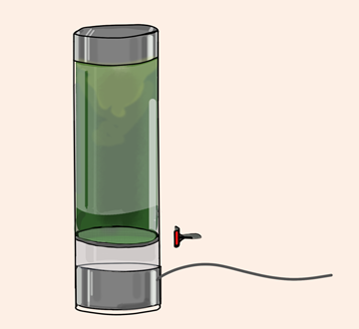
Figure 5.: Visulina Design

Final Visulina
The cost of building this design will be €848.85 (Appendix 1). For the final Visulina design there is a manual coffee maker stile filter making the product much less complicated and easier to use. It is a 660l tank with a fully functioning farm built around it. Because we could not test the design, we do not know how much fore the spirulina will create on the filter this will have to be researched in further testing. Once the testing begins a myriad of other problems will have to be solved. The design is still in its infancy and will have to improve before it will be reality. Yet it seems promising in the way it deals with problems dab lab has.
Figure 6.: Visulina Design Final

Build-plan
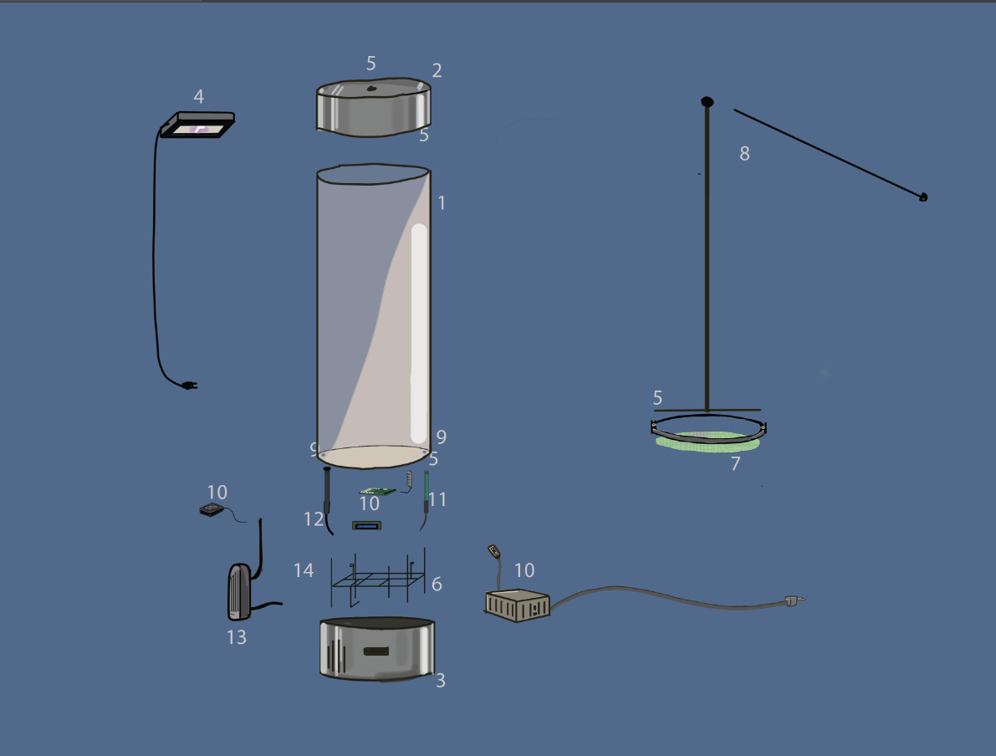
Figure 7.: Visulina Build plan
Part list
- Acrylic plexiglass tube
- Bottom part stainless steel
- Top part stainless steel
- Waterproof light
- Rubber lining
- Electronic supports 3d print
- Filter cloth
- Structure filter
- Isolation glue
- Astroplant kit
- Ph sensor
- Heater
- air injector
- Wires ( some water proof)

The hardest part to produce is the big acrylic cylinder tube because we only need one. Therefore, we buy the cylinder first and make the other parts custom to it. That way it will all fit the system without having too many big investments to have everything custom made.
First we would 3D print the encasing of the electronics. They will be placed below the water and have to be secured tightly while also covered with plastic sealed covers. (lunch box style with waterproofing tape on the wire holes.)
We will drill holes in the glass for the sensors and make the wiring watertight by first stacking shrink wrapping and after it just fits the hole we use water proofing glue to seal it completely. This however means it is harder to take apart and you will have to sacrifice a wire if it needs to come apart.
We would have to build the metal bits ourselves in a shop because it would be hard to find the correct measurements for the device. Those will have to be rolled first and welded afterwards.
Then all the electronics should be connected, put in the bottom and top, after that the holes should be insulated.
After that the filter mechanism will have to be built because it is a moving part it will be the hardest part to make. It is essentially a ring with a loose rubber strip on the outside that will lightly touch the tube. This will be attached to a rod that keeps the cylinder in shape. Within the cylinder there will be a micro filter cloth tightly bound to the cylinder. On 2 sides of the cylinder small holes will have to be made. These holes can fit the pumps and the sensors through it when you push the filter back to the bottom. The holes will be covered with a cut pizza style rubber top so you can push something solid trough but something liquid will be blocked.
This whole system is attached to a rod that sticks out at the top of the farm. That is where it is attached to a rod hanging down so you can push the filter up easily.
The filter should be connected to the top stainless steel in a way that when the filter is all the way up you can unscrew the stainless steel top you can get all the spirulina out. It is most likely not necessary but the top could get pressurized from the spirulina being pushed up a solution could be to make holes in the top and insulate them with a sheet TEMISH™ (Nitto, n.d.) paper an insulator that can let air through but not water. so water cannot pass through but air can during the harvesting with the filter.
Also to be able to feed the spirulina easily we should make a little hatch at the top so the user can refill or put in its feeding solution.

Business Case

This chapter will concern the business aspect of our internship. The business case is based on the DAB design of a Spirulina pillar that will enhance the building, but also the idea of forming a collaboration link between DAB, SEMiLLA and Kenya, and later more other countries in the Global South. In the beginning of this chapter, it was mentioned that Spirulina could either be given or sold to people as a sample to eat or as a resource for plant and insect production. However, as a municipality-funded establishment, the company itself was not allowed to make a profit at the expense of companies in the food sector operating in the area (DAB, n.d.). The municipality is funded by taxpayers who cannot be negatively affected by the lab absorbing their revenues. This is expected to be similar for other government-funded companies.

Competitors
As is evident by the success of the DAB lab in attracting many companies in the short period since its inception, people and companies are interested in coming together to share knowledge. That is the case in the South-Western delta but also in other parts of the Netherland. An example of such an innovation hub we as Frugal Innovation students got to experience during our minor was The Hague Tech Hub, which similarly to the DAB lab offers working spaces for both individuals and companies, enabling proximity-based knowledge sharing. The innovation hubs can also be part of a bigger scheme for innovation. Techleap, formerly known as StartUpDelta, is an organization with the motto “building opportunities, communities and a thriving start-up ecosystem in the Netherlands”, with over 7,500 startups being linked to the platform (Techleap, n.d.). However, DAB lab focuses on the Agri-food sector specifically. Identified competitors in this industry in the Netherlands are Foodvalley NL, NAFTC and AgriFoodInnovation, which will be described below.

Foodvalley NL
Foodvalley NL was founded in 2004 and is based in Wageningen, where one of the best universities for agricultural studies in the world, Wageningen University & Research, is also located (Foodvalley, n.d.). The company specializes in innovation in Circular Agriculture, Protein Shift and Food & Health. It provides support by connecting companies through its partner network, and offers special programs for young companies to grow, both nationally and internationally. To become a Foodvalley member, a company must pay an annual fee, and in return it can get an (inter)national reach through the Foodvalley business and promotion network. In addition, they can access laboratories, research equipment and experimental farms shared with Wageningen University, which would otherwise be hard to obtain by individual companies.

Netherlands Agro & Food Technology Center (NAFTC)
While NAFTC has its headquarters in Zoetermeer, it has an extensive international presence with offices in China, India and Vietnam and plans to open new offices in East and West Africa and Indonesia (NAFTC, 2015). The organization operates the offices to facilitate business in agriculture-related sectors internationally, with the Dutch mindset of providing a “sustainable source of healthy, safe food that is produced with respect for nature and the environment”. Through its operations it gains knowledge on international innovation and developments in the sector, which is shared with companies that become members of NAFTC. Primary sub-sectors the company focuses on are the horticulture chain, animal (feed) chains, the potato chain, food processing and technology, and agro logistics. The company is linked to the technology organization FME, the Dutch government and a plethora of other companies.

AgriFoodInnovation
AgriFoodInnovation targets the North-East Brabant area in the Netherlands and is proximity-wise the closest competitor of the DAB lab (AgriFoodInnovation, n.d.). Similar to DAB, the company presents itself as a network organisation which brings together companies and research institutes to inspire innovation in the agri-food sector. It views the future of agriculture as ‘precise, valuable, circular and connected’. To achieve innovation in the sector, the company has solidified goals into ‘moonshots’, which are concrete and disruptive improvements. Its three main moonshots are a ‘smart pig chain’, ‘digital crop chain’ and ‘valorisation of plant streams’. In addition to its partners, the organization has close ties with HAS Hogeschool, Technische Universiteit Eindhoven and Wageningen University & Research.

Attracting people
Based on market analysis and interviews, we found that young professionals and (university) students are in high demand for all agri-food hubs (AgriFoodInnovation, n.d.; A. Hessels, personal communication, 23 September 2020). However, students are not attracted to the industry, as illustrated in FIGURE SOCIAL STUDY. The abovementioned competitors of DAB attract the target group by collaborating with universities, and organizing knowledge events, such as AgroFoodInnovation does with the (online) Dutch Technology week (AgroFoodInnovation, n.d.). Some doubt the effect of open days on attracting students, such as Arno Pouls from Cosun, a partner company of the DAB lab that formerly owned the building the lab resides in (A. Pouls, personal communication, 21 January 2020). Instead, he vouches for internships and working with universities, as this solved the issue of young people not being interested in the agri-food sector some years ago. When the issue of attraction was raised with students in our survey in, many still mentioned they were not attracted to the agri-food sector. To learn more about the sector, reading was by far the biggest preference, followed by visits, open door events and internships respectively (Figure 1). While internships and physical visits could function as a better way to retain students in the industry, clearly lower-effort actions such as reading about the sector make a difference as well. Additionally, the survey shows people would only be slightly more interested in agri-food hubs when there is a space technology exhibition, as opposed to the view expressed by SEMiLLA and the DAB lab that it would make a significant difference (R. Lindeboom & A. Hessels, personal communication, 23 September 2020). When people can taste a sample grown by the space technology however, respondents would display a significantly bigger interest in visiting the agri-food hub (Figure 3).
The best way to attract (university) students would thus be a combination of publishing articles that are written with the target group in mind, while the visit itself could benefit from our Spirulina product.

Marketing
This paragraph will explain the marketing aspects of our product using the Jerome McCarthy marketing mix, also known as 5P’s, to give a coherent overview of our plan for the DAB lab

Product - As illustrated in figure 6, our Spirulina tank ‘Visulina’ will be see-through so the process of growing Spirulina can be viewed clearly. While the function of the tank is growing Spirulina, the concept of our product is designed to spark interest into the agri-food sector and the role of the microalgae in it. Through the product and social media, which will be further elaborated in ‘Promotion’, people can learn about the idea of Frugal Innovation and our project in Kenya, and in the future in other countries in the world.
Price - The price of Visulina will be €875, which covers the total costs of €848.85 (Appendix 1) and a mark-up of 3.1%. Currently, our product is not based on making a profit, as we were striving to make only one version for the DAB lab. Thus, the price is almost exactly the same as our costs including labour. However, if there is more interest for our product we would increase our price to have a profit margin for producing the tanks. In that case, we could have a price of €975 which includes a profit margin of approximately 15%.
Place - The best location for our product within the DAB lab would be in the cafeteria. While the entrance hall is the first place people see when they enter the building, it is rather small compared to the cafeteria. Based on our visits to the company, visitors are received in the cafeteria, where they will start their tour of the building. Because we would be handing out samples of Spirulina for people to tase, proximity to other eating establishments where we can store plates or clean dishes is beneficial.
People - The product caters to visitors of the DAB lab, and its function as an educational exhibit makes it suitable for high school and university students that the company wants to attract. In general, visitors of the DAB lab have a stake or an interest in the agri-food sector in the Netherlands, and our exhibition could attract them further to the sector.
Promotion - The Visulina tank will not have a significant promotion campaign, but will attract attention through its presence in the DAB lab. People who are interested in exhibiting a similar tank in their company, school or home will be able to contact us via the contact information that will be on the tank. Additionally, we will ask the DAB lab to create a page for our product on its website www.deltaagrifoodbusiness.nl where our concept of the tank and our project in Kenya is explained for people who desire to learn about it. Lastly, we will create an Instagram page where people can stay connected with us, and where we will update them on our project. An earlier experiment has taught us that it is easy to gain ‘followers’ and get interaction on the platform if we follow similar pages back, which leads to a better-known image and knowledge about our project. Instagram is especially suitable as it caters to teenagers and young adults, the precise group that the DAB lab wants to target.

DAB lab Conclusion

The conducted survey indicated a lack of interest in the agri-food sector, which could be increased by publishing articles about the sector or organising open days. Based on our survey, the visitation of agri-food innovation hubs is made more interesting by either connecting a story about space technology to it or sampling food that is made by circular space technology. Concretely, this means the product designed for the DAB lab needs to include corporate storytelling, during which we connect a story about sustainable technology used in space to the product itself. Furthermore, a green image, which can be improved by the Visulina farm, helps increase the attractiveness of the company to young people.
The Visulina farm is an easily monitorable system that is meant to grow Spirulina in an observable manner that can be used both as a device used for promotion as well as an addition to the building ecosystem.

Limitations to the research include the focus on an accessible student group that is not necessarily representative. More detailed questions need to be asked to find the reasons for the discovered lack of interest in the agri-food sector. The other target group of DAB, namely young professionals, was not elaborately looked at, which could be done in future research. Additionally, the product is custom made for the DAB building but due to limited feedback we do not know if it is tailored to their needs. Regarding the building ecosystem, carbon absorption in the building has not been thoroughly analysed, again due to a lack of communication with the DAB lab. The schematics of the building did also not provide clear insight into the current air circulation setup. The system was not made into a physical construction, and tests with strangers were impossible, and thus the system has not been tested. This means that there is no proof that the system will be used or will have a big impact on the intractability of the building and the companies in it.

In the second part of the report another Spirulina farm is introduced with the focus on Kenya. After completing the project, we think this farm could be of interest to the DAB lab since it has the potential to CO2 filter the whole building (in theory).

Chapter 3: Social Study

Connection Kenya and the Netherlands
To create a more frugalized innovation that matches what we learned during our minor, the Spirulina tank will not only be designed for the DAB lab, but also for production in Kenya. Thereby, the design will be modified to fit local needs. Kenya was chosen as the first starting point to implement the product because of local connections in the agricultural sector, which could then be linked back to the DAB lab. Additionally, many projects are working with Spirulina as a food supplement found in Kenya (Piccolo, 2011), which indicates an existing acceptance of this supplement and an existing market and distribution channels for our product. Bearing future expansion of the product in mind, we are focusing on specific locations in Kenya first but we are developing a frugal innovation that is modular and scalable and thus implementable in various countries.

Problem Analysis Kenya
The SDGs we are tackling with our product in Kenya are “Zero Hunger”, “Decent Work and Economic Growth”, “Good Health and Well-being” and “Responsible Consumption and Production”. The contributions we are making to these goals will be explained in more detail in the following. .

Beneficiary 1: Fisheries:
Our main clients and one of our beneficiaries in Kenya are fisheries working with artificial ponds, selling their fish on the domestic and international market. Due to their expertise of fish and water products and their existing water resources, they can easily learn how to grow Spirulina to obtain an additional, more diversified income source (Piccolo, 2011). Pond growth and harvest of Spirulina is relatively similar to growing fish using aquaponics (Piccolo, 2011). Due to heavy fluctuations in the local climate, fishermen would benefit from diversifying their income sources, whereby Spirulina would be an ideal solution because of its easy growing and harvesting process and the limited amount of resources needed. According to an interview conducted with Collins Apuoyo, the team leader of the NUTEC project, which aims to increase the income and climate resilience of low income households in Northern Uganda, fishermen are often taken advantage of by vendors. These vendors wait until the fish is close to its spoiling time due to a lack of cooling equipment and then buy it for an undervalued price because the fishermen are desperate. This claim is validated by a marine research report from Wageningen University that found that most fishers sell their product to an intermediary (vendors), who have a monopoly on the market and regulate prices (Hoof and Steins, 2017). The income of fishers varies according to climate, pond size, type of fish and total area, but according to an article in Tuko (one of the leading newspapers in Kenya) could make up to 60,000 to 100,000 KSH monthly (Aswani, 2018). Comparing this to the national average income of 147,000 KSH per month (Salaryexplorer, n.d.) it is obvious that an additional income for fishers would be beneficial. With an additional product that comes in the form of dried powder and thus cannot spoil easily, the fisherman would increase their chances at growing their income, which contributes to SDG number 8: decent work and economic growth. Thereby, our product specifically targets the indicator 8.2: “Achieve higher levels of economic productivity through diversification, technological upgrading and innovation, including through a focus on high-value added and labour-intensive sectors” (United Nations, n.d.). Additionally, the product works towards SDG number 2 (zero hunger) under the indicator 2.3: “By 2030, double the agricultural productivity and incomes of small-scale food producers, in particular women, indigenous peoples, family farmers, pastoralists and fishers, including through secure and equal access to land, other productive resources and inputs, knowledge, financial services, markets and opportunities for value addition and non-farm employment”. Our product will combine the different growing, harvesting and testing steps into a single design and make the whole process as circular as possible.

Beneficiary 2: Children under five:
Our main beneficiary will be children under five years of age, whereby other demographic groups will of course also benefit from our product. The data collected in the 2014 Kenya Demographic and Health Survey (KDHS) demonstrated that 25% of the children under five were stunted within the country (National Bureau of Statistics-Kenya and ICF International, 2015). Especially during the first two years of a human’s life, malnutrition can lead to irreversible long-term effects that have a negative influence on human development and educational achievement (Ministry of Health, 2011).
A micronutrient survey conducted by the Kenyan Ministry of Health in 2011 shows that children under 5 exhibit the most severe micronutrient deficiencies, which is why we will be focusing on them with our product. 36% of children under five in Kenya suffer from anaemia. In addition, iron deficiency is prevalent in children under five with 21.8% due to the consumption of poor complementary foods lacking bio-available iron (Ministry of Health, 2011). 83,3 percent of the same age group had low plasma zinc, which indicates zinc deficiency as a major public health issue (Ministry of Health, 2011). Zinc deficiency levels varied according to income classes of the individual households with poorer households showing a higher prevalence (89 percent) than richer households (75 percent) (Ministry of Health, 2011). With 9,4% of preschool aged children being vitamin A deficient, they are the demographic group most prone to this deficiency (Ministry of Health, 2011). For our project this means that we need to find a food (supplement) that is rich in vitamin A, iron and zinc.
Malnutrition also includes obesity and overweight in young children, which originate from rapid changes in dietary and physical activity patterns (Kimane-Murange et al., 2015). Oftentimes, low-income households only have the means to purchase cheap, low quality food lacking certain nutrients but being rich in fat and simple carbohydrates (Apuoyo, 2020). In addition to the high levels of under-nutrition explained in the previous paragraph, substantial levels of overweight/obesity have also been observed throughout Kenya. At the national level, 9% of children are overweight or obese (Kimane-Murange et al., 2015). Obesity often leads to cardiometabolic diseases including diabetes and hypertension (Kimane-Murange et al., 2015). This indicates the need for foods that are cheap but nutrient-rich and that help regulate health risks related to obesity such as high blood pressure and sugar levels.
Experts disagree on macronutrient intake recommendations, but we will use the European standards to assess the level of macronutrient intake in Kenya. Children aged under four are advised to consume around 14 g of protein per day, while children aged 4-6 are advised to consume around 19 g of protein per day (WHO, 2000). To make these recommendations more accurate, we will work with the measure that under 1 g protein per kg body mass in children is considered insufficient (Manary, 2013). A study conducted in Kenya and Nigeria showed that more than half of the children under 5 (53%) do not get enough protein (Manary, 2013). The average national protein intake of Kenyan children was 1.2 g/kg +/- 0.9 g/kg, which indicates that we need to develop a product that offers a stable protein source. The numbers on how much protein exactly is missing per child are hard to generalize due to the recommended weight of children under 5 changing according to their age. Furthermore, do some children have higher deficiencies than others. We can calculate that at most 0.9 additional grams of protein per kg body mass is needed, which amounts to a maximum of around 4.5g to 18g protein that is needed in addition on a daily basis varying according to age. To guesstimate a specific number of people each Spirulina farm would help, we are further working with 10 additional grams of protein daily per malnourished child.

Solution Fit Spirulina
Spirulina is the perfect solution to these national public health issues because it contains high levels of minerals including iron, zinc, magnesium, calcium and potassium (Khan et al., 2005). Furthermore, it contains vitamin A, various B vitamins and vitamin E. With 70%, the protein content of Spirulina is ten times more than the protein content of soybean and three times more than that of beef (Khan et al., 2005). According to the WHO, Spirulina is one of the greatest super foods on earth and NASA and other space companies consider it a great compact food for space travel due to its nutritional value. Therefore, it connects the different components from our internship, namely space technology, frugal innovation and the agri-food business sector.
A diet with Spirulina supplementation significantly reduces blood sugar levels and glycated serum protein levels confirming the hypoglycaemic effect of Spirulina (Khan et al., 2005). The dietary intake of GLA, which is found in Spirulina, can help in arthritis, heart diseases and obesity (Khan et al., 2005). For these reasons our product would not only help underweight people, but include all kinds of malnutrition. Mainly women are found to be obese on the national level (Kimane-Murange et al., 2015), which makes our product even more viable because mothers who buy the product for their child can also benefit from it and the other way around. Thereby, it is important to note that Spirulina is not a product that heals obesity by reducing weight but can function as a remedy for the by-products of obesity such as high blood pressure levels. The health-enhancing components of Spirulina work towards SDG number 2: zero hunger. Indicator 2.2, which reads: “By 2030, end all forms of malnutrition, including achieving, by 2025, the internationally agreed targets on stunting and wasting in children under 5 years of age, and address the nutritional needs of adolescent girls, pregnant and lactating women and older persons” (United Nations, n.d.) is especially supported by our product by delivering vitamins and micronutrients.
Moreover, Spirulina species show antiviral, anti-bacterial, anti-fungal and anti-parasite activities (Khan et al., 2005). Spirulina polysaccharides inhibit the replication of several enveloped viruses, such as herpes simplex virus, influenza virus, mumps virus, human cytomegalovirus and HIV-1 (Khan et al., 2005). Spirulina possesses anti-inflammatory, antioxidant, membrane stabilizing functions in various tissues (Khan et al., 2005). This could benefit other demographic groups in Kenya besides children under five.
Our product would increase the protein intake of our beneficiary due to its high protein content. Thereby, the increase of protein depends on the amount of daily Spirulina intake, but the minimum dosage of a single tablespoon (7g) already contains 4g protein, which covers the additional protein content needed by most children under 5. Children with a severe protein deficiency are advised to take more than one tablespoon of Spirulina a day to ensure the recommended protein intake. This means for our project, that malnourished children under 5 should be advised to a daily intake of around 2-3 tablespoons of Spirulina. By supplementing children’s diets with protein, we are supporting another indicator of SDG number 2, namely goal 2.1: “By 2030, end hunger and ensure access by all people, in particular the poor and people in vulnerable situations, including infants, to safe, nutritious and sufficient food all year round” (United Nations, n.d.).

Potential - Urban Food Deserts
Urban food desert is a term describing the phenomenon of a lack of certain foods in certain areas of cities (Wagner et al., 2019). This includes analysing the relationships between income, mobility, time, transportation means, household structure, availability and types of retail locations, education, structural inequalities and dietary diversity (Wagner et al., 2019). Specific areas in Nairobi work as an example for urban food deserts: almost half the households do not have a regular access to supermarkets and around 20 percent of the households with a regular access to supermarkets are food insecure (Wagner et al., 2019). Especially in these areas, healthy foods and certain nutrients (as analysed above) are lacking, creating potential to implement a frugal innovation offering nutritional, healthy foods at a cheap price. According to these findings, the potential of Spirulina powder is great in urban food deserts. For the future, implementation of Spirulina farms in various sizes and forms could be done within these areas to generate a stable, nutritional food source available and accessible to all.

Local Conditions and Spirulina Growth
With only 3% of the total area being water, Kenya has limited water resources (WRA, 2018). Only 81 000 km2 out of the total area of 582,646 km2 are classified as non-arid and profitably usable (WRA, 2018). Challenges do not only include water scarcity, but also its variability, climate change impacts and water pollution (WRA, 2018). This means for us, that our product needs to be water-efficient and circular to only need an initial amount of water or that it needs to be placed in a location with available initial clean water sources and then distributed to the consumer. We are adhering to these constraints by placing the Spirulina farm in fisheries with available resources first and then selling it to the beneficiary 2. The water used within the Spirulina growing system we are creating must be recycled, which is why our Spirulina culture will use 25% of the water needed to grow soy, 17% of corn and 2% of water required for beef protein (Habib and Hasan, 2008). The water-efficiency of Spirulina supports SDG number 12: responsible consumption and production. Especially indicator 12.2., which reads “By 2030, achieve the sustainable management and efficient use of natural resources” (United Nations, n.d.) is considered.

By 2022, all of Kenya will most probably be connected to the electricity grid (iea, n.d.). The electricity demand is expected to grow due to population growth, which means for our product that it should be energy-efficient. Currently, two-thirds of Kenya’s electricity comes from bioenergy, but this share is projected to decrease due to an increase in the use of geothermal energy (iea, n.d.). In addition to the grid being unstable, bioenergy is not the most efficient energy source, making it more important for us to use an energy-efficient product. The energy efficiency of Spirulina is 5 times higher than soy, 2 times higher than corn and over 100 times higher than grain-fed beef (Habib and Hasan, 2008). More about the design of the frugal Spirulina farm and how it is more resource efficient can be found in Chapter 5 .

According to Collins Apuoyo, who we have introduced before, land is limited in Kenya and low-income families lack the necessary space to be self-sustaining and earn an additional income for other necessities. The FAO found that 825 ha of land were used for aquaculture in 2009, which were operated by 6,328 fishers (Piccolo, 2011). If all land were distributed equally, every fisher would have 1,303 m2 of land available for aquaculture. Accounting for an unequal distribution of land between the fishers, they would still have enough space for a container with the dimensions of 12.2m x 2.4m x 2.7m. The dimensions of the farm come from standard shipping containers that we are using (Chapter 5) because of their frugality. Second-hand shipping containers function as relatively cheap, sustainable and easily transportable material. Throughout the subsequent phases of the business plan (Chapter 4), the dimensions of the Spirulina farm would have to decrease significantly in order to be able to be placed within urban environments. This can be achieved by using vertical space efficiently through decreasing width and length and increasing height.

Consumers and Distribution Channels of Spirulina
Kenya is a cultural melting pot with over 40 ethnic groups living within the country (Diningwomen, n.d.), which leads to a diverse eating culture. The main components eaten throughout the country include cereals, meats and vegetables. With an average yearly consumption of 3.4 kg fish per capita, the consumption of fish is not as widespread as in other East African countries like Tanzania and Uganda, which consume double the amount (Rothuis et al., 2014). This should not pose a problem to our product distribution though, because the consumers and distribution of fish fit our goal as explained in the following.

Case studies analysing the consumers of fish in Kenya show some differences, but are similar in their main observation that the high-income class eats more meat like chicken and beef while the middle to lower income class consumes more fish (Obiero et al., 2019 and Esilaba et al., 2017). This means that our clients (Fisheries) already existing customers show overlapping features with our beneficiary, who we want to get the product to. Apuoyo claims that very low-income households only have the means to consume fish about once a week. This statement reinforces the assumption that our target group has access to fish and thus the Spirulina.

Fish for the domestic market is mostly sold fresh, but often also dried or processed. The product is mostly transported in traditional baskets and sold at local markets (FAO, 2015), which are one of the main sources for food used by the economic class of our main beneficiary. For longer national journeys, it is transported in road vehicles to the larger urban markets such as Nairobi, but also the central and eastern provinces (FAO, 2015). This means for us, that we have to create a Spirulina farm with the ability to dry the microalgae to ensure a safe transportation because the dried product is lighter than fresh Spirulina and does not spoil as fast as fresh Spirulina. Within the urban market, lower-income households often do not have a space to cook their own food meaning that they buy most of their food from street vendors (Tacoli and Vorley, 2016). This needs more research, but could be an opportunity for us to market Spirulina to street food vendors that can add it to the food they are selling.

While talking to people working on Spirulina projects in the Global South like Felice Mastroleo, a microbiologist working on a Spirulina growing project in Congo, it became clear that the social perception of algae in Kenya would pose a problem. According to Apuoyo, algae is seen as a toxic plant that is dangerous to consume. Both people gave the advice to mix the Spirulina with a staple food for people not to notice its colour and texture. This mix could be sampled at local markets to get people used to the idea of seeing algae as something nutritional and beneficial. Furthermore, we want to distribute samples and informational pamphlets or other hand-outs at local health centres to increase the awareness of the health benefits of the superfood.

Chapter 4: Business Case

This chapter will analyse the business aspect of our proposal. While a container-based farm for growing Spirulina is a unique business proposition as far as our research has shown, Spirulina itself is not new to the Kenyan market. Various organizations have been engaged in bringing the superfood to the market, with their target groups ranging from health-conscious consumers who buy the food for its superb health benefits to NGOs and governmental organizations that distribute it to people suffering from malnutrition. Often, the product is sold in powdered form, giving it more versatility and a longer shelf- life (Persistence Market Research, 2017).

Spirulina market
According to the United Nations’ Food and Agriculture Organization (FAO), demand exceeds supply due to lack of funds and resources in western Kenya (Piccolo, 2011). As mentioned in Chapter 3, this could partly be attributed to a large population of underweight and overweight children: 11% of all children in Kenya are underweight (National Bureau of Statistics-Kenya and ICF International, 2015). In total, this amounts to 2.3 million out of 21 million people under 19 (CIA, n.d.). Another factor could be the high occurrence rate of HIV/AIDS, as 1.5 million inhabitants suffer from it (Lupia & Chien, 2012). HIV and the potential following stage of AIDS can result in the body entering a catabolic state - where the body does not obtain sufficient protein and other nutrients - and additionally increasing the severity of pre-existing malnutrition (Ivers et al., 2009). Combined, the two factors form a group of 3.8 million people that would significantly benefit from consuming Spirulina.
The malnourished are not the only people consuming Spirulina. The cyanobacteria is available in many health stores, both in the Netherlands and in Kenya, for those who would like to add more nutritional value to their meals (Piccolo, 2011). Market researchers estimate the Global Spirulina market to range from $348-$700 million, with an average Compound Annual Growth Rate (CAGR) of 10.1% for the next 5 to 6 years (Sumant & Kunsel, 2019; Persistence Market Research, 2017; KBV Research, 2019). It is comparable to the 10.05% CAGR of the Brokerage & Investment Banking sector in the United States (Damodoran, 2021). Out of all continents, North America is the top consumer of Spirulina, and is expected to continue that trend, while Africa is an emerging consumer of the product (Sumant & Kunsel, 2019). Africa is not well-represented in most reports, with many of them grouping the African market together with Latin America and the Middle East (LAMEA). However, the Spirulina market in LAMEA is expected to grow with the highest CAGR at 11.66% from 2019-2025. The high expected growth rate is a result of governments from African countries such as Ghana and Angola actively trying to support the production of Spirulina as a food source, next to the increased use of Spirulina in the medical industry and growing skin and haircare market (KBV Research, 2019). A rough estimation of the Spirulina market size in Africa could be obtained by dividing the total market by the amount of geographical categories, which would result in $87-$175 million for the LAMEA market and $29-$58 million for the African continent.

Competitors
There are five main competitors in the Spirulina market in Kenya. While other small farming projects have been identified, the five competitors that will be described in this paragraph can be found in research papers by individuals and NGOs, articles online and/or (online) stores that sell them.

Dunga
Dunga Spirulina is a privately held company with a production facility in the Dunga village of Kismu in western Kenya. Its maximum production capacity could be 20 kg of dry Spirulina per day, but due to an unclarified lack of resources, its capacity is currently 5 kg per day (Piccolo, 2011). Dunga Spirulina caters towards the high-end segment of the Spirulina market, and markets it as an essential vitamin and protein supplement in powdered form (Dunga Spirulina, 2011). A bag of 100 grams of Spirulina powder was sold for 650 ksh in 2011, at the equivalent of $7.80 at the time (Dunga Spirulina, 2011). While the company only has a singular production facility in Dunga, it distributes its products throughout various stores in Kenya. The most prominent distributors are the Healthy U chain stores, which are located throughout the entire country, including the cities Nairobi, Mombasa, Nakumatt and Kismu. Dunga products are also available in the supermarkets of Nakumatt and a handful of other health stores in Kenya (Piccolo, 2011).

Galaxy
Galaxy is a youth-based organization that produces Spirulina in various locations around Kakamega, also in western Kenya. The organization is closely related to the University of Masinde Muliro and the Kenya National Federation of Agricultural Producers. Its total daily production was 1.75 kg per day in 2011, 1 kg of which was grown in greenhouses near the university to avoid contamination. Galaxy uses its Spirulina to combat malnutrition in the area, and sells the remainder in powdered or capsule form, thus targeting both the high- and low-end segment (Piccolo, 2011).

IIMSAM
IIMSAM stands for ‘Intergovernmental Institution for the use of Micro-algae Spirulina Against Malnutrition’. The organization was established by the United Nations Economic & Social Council in 2003, and strives to combat Sustainable Development Goals (SDGs) 1 (No Poverty) and 2 (Zero Hunger) (IIMSAM, 2003). IIMSAM has operations in western Kenya and produces approximately 3 kg Spirulina powder per day, and with its 20 production days 60 kg per month. Similar to Dunga, potential production could be much higher for IIMSAM. The organization has 10 ponds which require 12,000 m3 of water per pond, which does not yet take evaporation into account. A lack of water resulted in the use of just a singular pond at the IIMSAM facility. Even so, it provides malnourished children and people suffering from HIV/AIDS with Spirulina, an amount of 150-200 people at peak production. While normal consumers need approximately 10-12 grams per day, the target group of IIMSAM needs a much higher amount. The NGO additionally serves as a training facility, as both the owner of Dunga Spirulina and students working at Galaxy have received a degree of training at the IIMSAM production facility.

Tiwani
Similar to Dunga Spirulina, Tiwani is a ‘regular’ seller of Spirulina algae that targets the high-end market. Unlike the aforementioned organizations, Tiwani is located in southern Kenya near the coast bordering the Indian Ocean (Tiwani Spirulina, n.d.). It sells Spirulina in powdered and capsule form, but also combined with Moringa, a leaf-based potent source of vitamin A and C. In powdered form, 75 gram of Spirulina is sold for $10, according to the company’s website. Tiwani distributes its product through similar channels as Dunga Spirulina, namely the Healthy U chain store, small stores and grocery stores, but also online via platforms that offer free shipping in Kenya. In addition , there are two stores in the neighbouring country Uganda. An estimation of Tiwani’s production capacity was based on the fact that they have a production facility of 1 acre, which would produce approximately 4,223 kg per year if 75% of the surface could produce Spirulina, and ponds would be 20 cm deep (Appendix 2). According to calculations from a 2012 FAO report, the production could be as high as 9000 kg per year (Appendix 2).

Thriving Green
Thriving Green originated as a student initiative. German students worked with locals to build three 60m3 pools to provide Spirulina to people suffering from malnutrition in the Turkana region in northern Kenya (Thriving Green, n.d.). The project has provided work and food for many and has won awards, such as the GreenTec environmental award in 2017. Thriving Green has recently opened a new facility in Ebukanga, adding another 60m3 raceway pond to its portfolio (Bleisteiner, 2019). In total, the organization is estimated to produce 12.7 kg per year, which is expected to increase as the founders have expressed their interest to serve 400 people in the future (Eco Africa, 2018).

Kenyan Spirulina production
Based on the production of the companies in the previous paragraph, we estimate current production between 7,419 and 12,197 kg. We take 12,197 kg per year as current production to make up for other smaller Spirulina-growing projects that were not used in the calculation. The majority of sales can be attributed to the high-end segment as illustrated by the production of Tiwani and Dunga. Tiwani sells a 75g package of Spirulina for $10, or $133 per kg. According to the Food and Agriculture Organization (FAO), the lowest price in Kenya is €70 or $84.94 per kg, but products sold at that price have a low micro nutrient and protein content (Piccolo, 2011). Considering Tiwani’s price, the yearly revenue for Spirulina in Kenya is $1.62 million. Assuming the Kenyan market grows at the same rate as the LAMEA market at 11.66% we can expect the demand for Spirulina to be $4.39 million, for which a production of 21,170 kg is needed.

Year | Market size in kg | Market size in $ million
2020 | 12,197 | 1.62
2021 | 13,619 | 1.81
2022 | 15,207 | 2.02
2023 | 16,980 | 2.26
2024 | 18,960 | 2.52
2025 | 21,170 | 2.81

Porter’s 5 forces:
To examine the competitors and the Spirulina market in further detail, the Porter’s 5 forces framework can be used. The framework uses the concepts of suppliers, substitutes, buyers and entrants. While our product will be a Spirulina growing container (Chapter 5), this paragraph will analyse the market for Spirulina itself. In that aspect, suppliers are those who provide labour, raw material, components or expertise for the competitors mentioned in the previous paragraph, whereas it would be the producers of components for the container if this paragraph was container-focussed.

Bargaining power of Suppliers - Excluding labour and components needed for the initial construction, the competitors barely rely on suppliers. Spirulina reproduces exponentially, and thus only an initial investment into the algae must be done. Some companies rely on electricity to keep stirring the algae, while others either use solar panels, do it manually, or do not stir at all. Labour, on the other hand, is a recurring expense, as people need to oversee the production and harvesting. Kenya’s overall unemployment rate is low at 2.65% in 2019 which is similar to the 2.98% in the Netherlands (Plecher, 2020; Plecher, 2020). This implies that few people are looking for a job, and an open position might be hard to fill for companies. The issue could be solved by offering a competitive wage and having a good employee retention policy. The bargaining power of suppliers is thus low.

Threat of Substitutes - Substitutes can be either products with a similar purpose to Spirulina, such as Chlorella or Moringa, or products that people would buy if they did not buy the micro algae such as fish (Koyande et al., 2019). The latter is traditionally used in cuisine, but few people can afford it each day (Chapter 3). As for other superfoods, Moringa is the only one that is sold by Spirulina producers in Kenya. The protein content of the Moringa is similar to eggs, which is approximately 14% (Alegbeleye, 2017). Together with Spirulina, Chlorella dominates the global microalgae market as a superfood, and both can be used to feed animals (Koyande et al., 2019). Spirulina has a slightly higher protein content at 60-70% compared to 50-60% and is thus also better to combat malnutrition. Growing Chlorella is done in a similar manner to Spirulina as well, with circulating water, sunlight and an average temperature of 25C needed for it to thrive (Allaguvatova, Myasina, Zakharenko & Gaysina, 2019). Considering the availability, protein content and consumer knowledge of all substitutes, Spirulina is the dominant superfood. Fish as an alternative is more well-known in Kenya, but the protein content of Tilapia, which is consumed most in Kenya, is only 20% (Rothuis et al.,2014 and USDA, 2018). Most of Kenyan high-quality Tilapia is exported, and to protect the industry the government has implemented a high import duty of 25% (Rothuis et al., 2014). Combined with decreasing catches, this leads to the fact that Kenya has a shortage of quality fish (Rothuis et al., 2014). The protein content of fish is thus assumed to be lower than 20%. Spirulina could thus be the best option for people to meet their protein intake requirements, and the threat of substitutes is of medium interest.

Bargaining power of Buyers
According to the Kenya National Bureau of Statistics (KNBS), a middle-class Kenyan is anyone who spends between 23,670 and 199,999 Kenyan Shilling (KSH) a month (Odeph, 2019). This translates to $216.27 and $1827.42 (xe.com, 2021) . The bargaining power of buyers is measured by how they can pressure a business to provide better quality and lower cost. In our case, quality can be measured by the nutritional content of Spirulina. There are multiple strains of the microalgae, and the best content is from the products containing “Spirulina platensis'' or “Arthrospira platensis” (Algorin, n.d.). Additionally, tablets should contain a limited percentage of additives. This aspect can be missing for non-profit companies such as IIMSAM and Thriving Green, as they do not have a set packaging with nutritional information. However, the bargaining power of buyers is low for non-profit organizations. Both because these organizations distribute it for free (no lower cost) and because consumers seem to be satisfied with the product. While the non-profit companies do have some requirements for people being eligible for their product, it could hurt competition as no company would gain from selling something for free while having monthly costs. The concept of distributing products for free has been heavily criticised by recent literature, whereas frugal innovations that enable people to make a living from a company has started becoming the new status quo. However, the issue still exists, and thus bargaining power of buyers is of medium importance.

Threat of new Entrants
While setting up a Spirulina farm requires an investment of a Spirulina culture and equipment, the scale can differ significantly. Based on the competitor analysis, it can be observed that some production facilities were the result of student initiatives, similar to our project. As the Spirulina market is expected to grow, so are production facilities in Kenya. However, many existing companies struggle with a lack of water, even when they have the funds and production facility to produce Spirulina. Additionally, knowledge is a limiting factor, as there are only a limited amount of biologists or Spirulina experts in the country. By working together with universities, both from the Netherlands and Kenya, this threat can be reduced. Thus, the threat of new entrants is low.

Business phases

Phase 1 - Fisheries (land-based) - 2021-2025
Phase 2 - Rural farmers - 2025-2030
Phase 3 - Cities - 2030 onwards

To resolve the issues that competitors have, not only the design but also the business model of Spirulina farms must be adapted.
One of the biggest constraints for Spirulina farms is access to water. Land-based fisheries or ‘aquaponic farms’ already overcome this barrier, as they are raising fresh-water fish. Spirulina could prove to be an extra source of income for the aqua farmers. Thus, they are part of the first phase in our market penetration strategy. Unlike competitors, we would decrease the effect of (fresh) water scarcity and ways to obtain it, as aqua farmers could leverage their already existing channels such as wells to get it (I. van der Lee, personal communication, 26 January 2021). However, there is a limited number of aquafarmers, and they already sell fish (a protein source) to people at a considerable price (Apuoyo, 2020; Van der Lee, 2021).
We assume that a bigger need for Spirulina lies in other rural and urban areas. After analysing the aqua farmers’ water supply chain, we want to exploit their channels and connections and direct them towards rural farmers so it is possible for them to start a Spirulina production facility as well. Rural farmers often supply nearby cities in food, and in this way we could start introducing Spirulina to more people, without having any negative association with toxic algae (Apuoyo, 2020). The rural farmers benefit even more from our product, as Kenya has struggled with harvest destructions caused by locusts in recent years (Allgöwer, 2020). Spirulina in a protected environment is not affected by them, and could thus be even more beneficial in times of locust pests.
In the last phase of our strategy, we want to move to the cities where a significant amount of people live, from all kinds of economical/social classes. This phase marks a significant re-evaluation stage, where, among others, the Spirulina CAGR and market would have to be re-analysed. In Kenyan cities, there seems to be a lack of space, both in formal and informal settlements (Apuoyo, 2020). Thus, in this phase the design might also have to be adapted, such as decreasing the width and increasing the height, or potentially lowering the weight for the product to be able to fit on roofs.
Since rural farmers have been selling Spirulina in small quantities, at this time the algae is already known for its beneficial health purposes and we as an organization have an even better overview of the best production methods and transportation channels. By leveraging them and adapting to limited space in cities we should increase Spirulina consumption in the cities and reduce transportation distance and related CO2 emissions.

Chapter 5. Design
In Chapters 3 and 4, the idea of fish farmers as clients in Kenya was discussed, since they have access to water. This means the design has this group in mind whilst still being a good fit for non fish farmers. There are a total of 6,328 aquaponic fish farmers (Piccolo, 2011) in Kenya. They have a source of water, experience with health standards and access to the food market. They combine local market knowledge and space in a good way. Our calculations show that a production of approximately 14,126 kg is needed after Spirulina is exposed to the larger public for about 5 years (Chapter 4). Based on the amount of Spirulina produced as a food source right now and the normal increase of the agri-food sector in Kenya we expect 5% of the farmers would adopt Spirulina (this would be 316 farmers). This would give us about 316 producers. Each producer should produce 45 kg to satisfy our predicted need.
This implies they would have to produce about 3.8 kg a month, which is achievable in a single pond farm. However production is not always consistent so it would be preferable to aim for a higher production. This also keeps the price from going up easily. Therefore we want to aim to produce about 4.2 kg a month.
Because the famers are already farming fish the farm would have to be an extra add on to their existing farms so the farm should be set up to be simple but effective/productive. From our research we found that the farm should also be lockable, as this was advised by Collins (2020). This way producers can put the farm anywhere and only have to connect to a well or other water source that must be present on the spot. This concept pushed us in the direction of containers, a worldwide product that can be bought second hand all over the globe. We assume that most of the aquaponic farmers have a space that could fit the 17,000-19,000 Litre Spirulina farm.
Then we looked at the dimensions that the pool would have to be. If looked at the dimensions of a 40 ft container the pool right size pool can fit it (Gammer, 2020) and will be will be 32 ft (9.75 m) long to make sure there is room to fit processing and maintaining in the front of the container it can only be 7 ft (2.13 m) and to make the farm produce enough, the bath would have to be 90 cm deep. If we would have a more conventional design without a non-expandable encasement our measurements would most likely be longer and wider but more shallow to increase efficiency. However we think that a lockable container that houses the full process inside would be ideal for our beneficiary because in a smaller system like this user is sure that if they keep up the system they lock out insects and further limit the risk of contamination. This would limit the amount of work spent with the system so they are still able to conduct their business as usual.

Spirulina farming
The Spirulina farming cycles as defined by (aurospirul, n.d.) has 5 steps excluding the setup which means filling your tank and putting in the right nutrients.
The first real step is the cultivation where the algae grows. It is vital that the pH of the water is above 10 to make sure only the Spirulina is growing in the pond so it will not be infected. In the container we install a constant ph. meter so the farmer can be sure of the Spirulina’s heath. Normally you would stir the water a few times a day so the bottom Spirulina reaches the top and photosynthesis is happening, air/CO2 gets in the water and so the Spirulina does not burn. In the container design the pond is deep so we have a stronger air injection paddle on the whole time.
Harvesting is done by slowly running a 300-micron cloth through the water. After the Spirulina is filtered out. It must be washed by running water through it. This water should be run over the pool so water gets back in. Even though the room is closed off some evaporated water will be lost.
Afterwards, the Spirulina must be pressed to get all the water out. The Spirulina should be packed in the filter cloth, and subsequently put between two slabs on the manual hydraulic press.
To get the last water out, the Spirulina is dried in the solar dryer that makes use of a sun powered heater to have a constant enclosed heating solution. This is important because the Spirulina can get contaminated easily during the drying if it is too hot or if the oven is not enclosed. The drying should take approximately 4 hours.
When the Spirulina is dried it can be packed in paper bags and sold or can be shipped to be processed with another type of food because it is sold more easily that way. If the producer would prefer it, they can also buy a mold in which they can press Spirulina into tablets in the hydraulic press.

Modifications to the container.
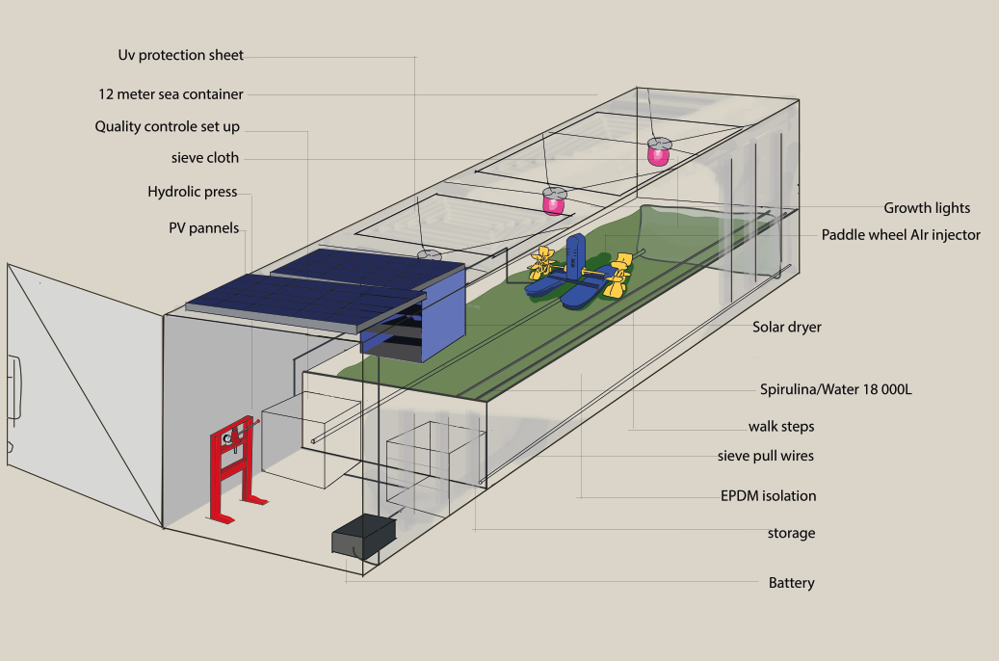
Figure 8.: Modifications of the Container
To get the container to a point where it can be used as a Spirulina farm work has to be done. All the components will be shipped to Kenya where the labour will take place. For a better look at the sizes see Appendix 3.
The first step should be checking if the container is sealed properly. When they are new they should be watertight but the quality can decrease and they will only be bought second hand. Because the container is not going to move much the leaks can be filled with isolation foam and put rubber on the outside.
After that the sun roof will have to be cut out and put back inside of the container to function as the divider wall for the bath. Once that is in place, the holes for the sensors and wiring should be made. A close able water hole is made in the back or side.
After this is done, the food grade pond liner is put in the bath shortly after all the wires and pipes will run through the holes and they will be properly sealed. Afterwards a quick leakage test needs to be done.
Now the roof needs to be prepared meaning that the PV and the solar dryer need to be mounted and properly attached. Whilst the sun roofs will be covered with UV protection sheets.
Now all the wiring should be attached to the sensors, lights, power supplies and batteries. Whilst the Astroplant kit is attached to its box where the farmer can connect to.
The filter pull wires are attached so you can use them to pull the big filter cloth through the bath. Then, the big clips you can attach the filter cloth to are installed. After this is done we can make the ladder at the right side of the bath that is meant so the farmer can walk in the space.
Once all the loose components are in place and secured to the container, the container will be ready for use.
Components
To make the system as frugal as possible the cheapest solutions to the steps of Spirulina farming were found. Yet all the different components that encounter the Spirulina still must be food grade. Specific products are linked Appendix 1.
The used hydraulic press is a manual (titian 12 ton press) which should be sufficient, cheap and does not use electricity. For the limited pressing that is needed this is a good fit for the container. The total footprint for the device is Height: 129.54 tall by 48.26 wide by 7.62 deep, which is little space that needs to be used wisely.
The chosen drying solution is the solar dryer. The drying process was harder to figure out; different sources stated different solutions, some used an expensive advanced low temperature oven, others used drying racks in black painted sages in the sun without any electricity. From our interview with Felice Mastroleo we learned that the drying process is a crucial part of the production that can easily spoil the Spirulina since bacteria can multiply fast in high temperature outside of the high ph. bath. A stable temperature of about 40 degrees Celsius for around 6 hours would be best (2014). The best solution was the solar dryer, a sun powered dryer that used the heat of the sun in combination with solar energy (Madhlopa & Ngwalo, 2007). This is a simple yet effective dryer that is not too expensive and fits attaches to the roof of the container.
The sun roofs are cut out of the roof and filled with UV protection sheets so during the day time natural lighting can be used. After dark the growth lights turn on to maximize productivity
The energy usage of the device was important to be independent of the national power grid because it is unstable and not available to everyone (Taneja, 2017). Besides the power outages caused by accidents, outages are scheduled at a regular rate (Kenya Power Care, 2021). It is important for the deep pond to constantly circulate, which is why we need an alternative power source. We decided to use PV panels, one that is included in the solar dryer and 2,290 watt PV panels on the roof. These panels' main purpose are keeping the light running during the night and the air paddle 24 hours a day in short intervals. The paddle needs a max of 0.37KW. So with 12 hours of daylight the 2 panels should be able to store enough energy to make it through the night. Without the circulation of the water and the air injection the Spirulina’s growth will stagnate and because the water flow stops and the Spirulina at the bottom of the tank will not reach the top, the Spirulina at the top will be damaged and the Spirulina at the bottom might die. That is why the paddle has the main priority when it comes to power usage. We installed a battery that the Pv panel runs into to supply the system with power at night or in times of limited sun. During day time we can leave the lights of and take advantage of the sun roof we made in the container.
Because CO2 has a big positive effect on the growth rate of Spirulina there thought if there was a way where somehow CO2 could be tunnelled into the device, but fisheries do not have too much emission.
Differentiation
We differentiate ourselves because we deliver the total Spirulina package at a much lower price than competitors. In some instances competitors were proposing plans to build at a price around €60,000 (Piccolo, 2011) where we are closer to 5,000 euros. Admittedly the other farm is bigger but a lot of these bigger farms lack water and thus do not make use of the full farm capacities. Besides that, we offer a compact system with good tracking of the Spirulina’s health.
We are also trying to create a stable market with smaller farms spread out across Kenya which saves in transport and makes sure the price is not driven up.
It is important to partner with university support that can monitor the spirulina if something is wrong with the colour, ph. or growth rates of the spirulina. That is why the project will strive to cooperate with a university that can aid in these short but paid check-ups.
Testing design
One of our main concerns was the quality of the Spirulina. In an interview with Mastroleo from SCK-CEN project - a MELiSSA project that worked with Spirulina in Congo - we learned that one of the main hurdles is to test the safety of the Spirulina.
Our first testing installation was built on Curacao because the climate resembles the Kenyan climate more than the Dutch winter climate does and it has similar power outage problems. It was a basic construction (Figure 9) that functioned as a means for us to find out how to grow Spirulina and how difficult it is to maintain a Spirulina colony. We kept the colony up from 3 December 2020 till 30 January 2021. During that period it had turned brown at some point due to overexposure to sunlight. It was analysed under a microscope by an expert farmer, and he stated it had partially died but later the spirulina was able to recover and become completely healthy. During the experiment we increased the amount of Spirulina culture from 2 to 6 litres.

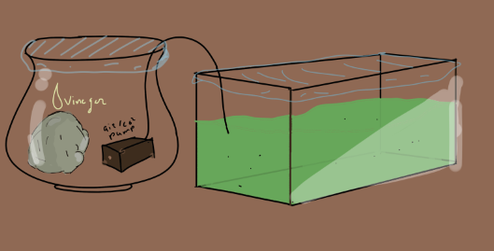
Figure 9.: Testing Design
From that experiment the following conclusion can be stated: a Spirulina farm can be kept stable under the following conditions:
- ph. above 9 (Mehar et al., 2019,)
- Moving water
- Protection from direct sunlight
- Temperature below 35 Celsius (Algae Research Supply, n.d.).
If these conditions do not apply for an extended period, the Spirulina should be checked.
Astroplant kit (test)
The setup of the Astroplant kit is easily understandable and thus useful for pilot projects. Sadly, the initial Spirulina did not get back to the Netherlands and the extra sensors were not available to test with. This meant that while it was nice to get a feel for the kit no actual test could be done.
Circularity
The system works with about 17,000 litre. Since water is mostly scarce and most fisheries use water from wells, the amount of water used should be limited as much as possible. Water filters that could use pee for the water were researched (like in Peter Scheers project) but such a water filtering system would be an investment too big for our beneficiary. Additionally, the negative reputation of the algae in Kenya would not be improved by growing it in filtered urine.
The solution fit would be to contain the water as much as possible, which is achieved by insulating the container as much as possible and making sure all water usage and extraction is tunnelled back into the bath.
All the energy of the system is derived from sunlight and is thus clean energy. The container is bought second-hand as we can use containers that are not rigid enough for sea travel but strong enough to stand still on land. The farm holds about 17,000-19,000 litres, which means the farm could absorb the CO2 that 28 people breathe out in a day. This might be interesting for the DAB lab as well.
Limitations
The system has its limitations and the conclusion will go deeper into some of them and why we made certain choices. Below a table highlighting the pros and cons of the container can be found.
Pro’s container | Cons container
Save lockable unit | Expensive
One package that can be structurally manufactured | Hard to expand
Reliable structure | One rigid size
Bigger production options | You rellie on second hand market
 | More complicated to harvest

Chapter 6. Financial plan

Legal requirements
Next to the technical requirements discussed in Chapter 5 and shown in Appendix 4, there are also some legal requirements the Spirulina production unit must have. The minimal requirement for food products in Kenya is the Kenya Bureau of Standards certificate for food safety (Piccolo, 2012). However, the informal sector for agriculture that does not have the certification is quite big. Other Spirulina companies such as Thriving Green produce the microalgae without a cover, but check the quality with a microscope afterwards. A better method, that was also used during the Curacao Spirulina growing project, is to use a cover to prevent anything from falling in or contaminating the algae. It is not known whether Thriving Green has the KBS certificate for food safety, but because their project has won international awards and has been expanding in Kenya, we assume they do. As our Spirulina would be grown in an even safer, controlled environment, we assume that obtaining the legal requirements would not be an issue.

Break-even analysis
It is essential for Spirulina producers to know how long it will take to pay off our container, and what to expect in revenues, profits and costs per month. Considering that the condition of our beneficiaries, malnourished children, might be caused by the inability to buy healthy food as Base of the Pyramid consumers, the costs of Spirulina should be as low as possible.

Costs and revenues
Chapter 4 revealed that the lowest Spirulina price in Kenya is €70 per kg when converted to euros, while the highest is €133. It is worth mentioning that the actual lowest price for Spirulina are products given away for free by organizations such as IIMSAM, but those do not constitute a sustainable business model, and are not accessible to everyone. Thus, we consider €70 as the lowest price for our calculations. As will be elaborated in the Marketing paragraph, the cost of a container for clients would be 675,000 Kenyan Shillings, or €5,092. Additionally, the Spirulina farmers would have to pay €45.75 in monthly upkeep costs, which covers project oversight by us in the Netherlands, one workday of student labour for quality checks and medium fertilizer which is needed every monthly cycle after Spirulina is harvested.
Based on a price of €70 and an annual production of 45 kg, annual revenues would be €3,150. Subtracting costs from revenues gives an annual profit of €2,601. This implies that the Spirulina container has a break-even point of almost 2 years, or 51 kg.

Carbon credits
Companies in the EU must obtain carbon credits for the amount that they go over the cap of CO2 they can produce according to the EU. They can buy the rights from companies that do not need them. The price for one European Union Allowance (EUA) is approximately €26, which is expected to increase to €40 in the upcoming years. Companies also voluntarily reduce their impact, in which case they buy Certified or Verified Emission Reductions (CER & VER). VERs prices are based on the way they are obtained. They can vary from €1 for big-scale solar plantations to €20 per tonne for small scale cooking or reforestation projects in either Europe or another country. CERs are the cheapest at €0.23 in 2018, due to a high supply and the fact that they might not be used after 2020 anymore (Fair Climate Fund, n.d.). We are most likely to be awarded VERs for our project (BusinessGreen, 2010). In 2014, Kenyans earned carbon credits from sustainable farming for the first time ever, at $24 (€22) per tonne of carbon dioxide absorbed (World Bank, 2014). Assuming we get the highest price of €20 per tonne, Spirulina farmers can expect an additional €1.80 in income, as Spirulina consumes as much as twice the amount of CO2 as the Spirulina produced (Piccolo, 2011). This amount declines as the price for the carbon credits price declines, and can amount to as few as €0.01. Thus, the revenue gained from carbon credits is insignificant.

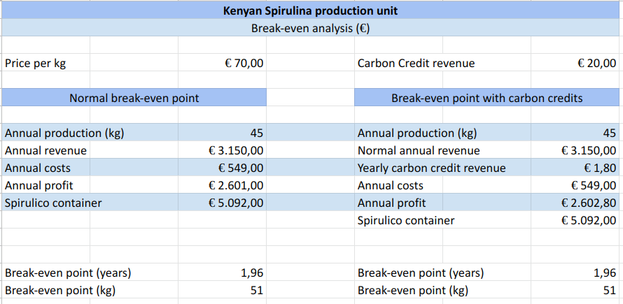
Figure 10.: Kenyan Spirulina production unit

Marketing
To give an overview about what will be brought to the market, the marketing 5P’s can again be used.

Product - Our product will be a Spirulina growing container by the name of Spirulico, with the supreme quality control systems and additional check-ups and consultancy from students and professionals in Kenya. It will be the cheapest production facility of its kind and can be paid off in 1 year and 10 months (Figure 10).
Price - The price will be 675,000 KSH which is approximately €5,092 (xe.com, 2021). This covers production and transportation costs, which combined amount to €5,005, and adds a low profit margin of 1.7% to make the price a round number.
Place - The selling of Spirulico will take place in Kenya, as we have identified a need and experts willing to help us there. As mentioned in Chapter 4, the initial focus will be on land-based (aquafarming) fisheries that are scattered throughout the entirety of Kenya. The second focus group will be rural areas that are close to cities, as the latter is the main customer group of rural farmers. The last target will be cities, which would lead to a decrease in the distribution channel and eliminate CO2 waste from transport by cars and trucks. In the case of success in the Kenyan market, the supply of Spirulico could be extended to neighbouring countries or other interested countries.
People - The business case focuses on three customers. Aquafarmers, rural farmers and city farmers. Out of all three, rural farmers are presumed to have the lowest income, and thus the lowest ability to purchase Spirulico. The people that would buy from our customers and benefit from our product, also called beneficiaries, are the malnourished, which includes both underweight and overweight people and people suffering from a deficiency of vitamins or minerals.
Promotion - After consulting with people living in Kenya who are either locals or expats, the best promotion strategy seems to be sampling the product on local markets (I. van Loon, personal communication, 19 January 2020). This would be done by our customers for the beneficiaries, according to our recommendations. Additionally, the project must be promoted via social media and Dutch agri-food hubs such as the DAB lab to attract international students to Kenya and to help with Spirulina control and setup through e.g., internships.

Evaluation: SWOT
While Porter’s 5 forces (5P’s) in Chapter 4 analysed the competition and risks of competition, it did not analyse the company-specific elements. To analyse the risks and benefits our product has, the SWOT analysis, which stands for Strengths, Weaknesses, Opportunities and Threats, can be utilized.

Strengths - Our biggest strength is that Spirulico has the absolute best quality control, with professionals checking the product when something happens to the Spirulina in the unlikely event that the control mechanics fail. Some other competitors also work together with university students to produce Spirulina, but in our case they play a supporting role in addition to the Spirulico container. Thus, the Spirulina producers do not have to be reliant on them, while still gaining from the knowledge professionals might have.
Weaknesses - While a client can technically scale up their production by purchasing more containers, this can at some point become expensive. A client might then prefer switching to standard Kenyan Spirulina farms that have worse quality control but can also easily be expanded. Additionally, our target consumers might not necessarily want to benefit the beneficiaries we had in mind. We cannot easily impose a price limit on the Spirulina they produce, which will allow them to target richer health-conscious consumers, and not malnourished children whose parents lack funds to buy the higher-priced Spirulina.
Opportunities - While Kenyan people are open to try new things, it is hard for them to come up with funds (Van der Lee, 2021). To capitalize on this difficulty, we could provide Dutch or other international subsidies or microloans for entrepreneurial Kenyans to set up a Spirulico facility.
Threats - As illustrated before, a lack of water is one of the biggest issues Spirulina facilities face in Kenya. This issue is partly resolved by the business model innovation that targets fisheries who already have water, and using that connection to provide others with water. However, the degree to which this is possible can vary in practice and per season. When a fisher’s well dries up, it has direct implications for his Spirulico farm and other Spirulico farmers they provide water for. Additionally, the acceptance of Spirulina could fall short of meeting our expectations, which results in our client having difficulty selling the Spirulina, or few clients being interested in buying products that grow Spirulina. Lastly, the possibility exists that clients get behind on their payment, especially the monthly one which they might perceive as unnecessary when their system runs well.

Chapter 7. Conclusion

We saw that only one competitor was focussing on international agri-food chains. While DAB has many international partners, we did not see how the company was very international. This could be a link in helping them become more so, and reaping the benefits by getting knowledge from agriculture chains & innovations in other countries. Furthermore, the DAB lab can benefit from the corporate storytelling approach by creating a story of the link to the Global South Design, which could increase young professionals’ interest in the company. The product we designed during our internship could also help the DAB lab by creating a sustainable reputation due to the implementation of circular technology.
The beneficiaries in the Global South could benefit from the product in different ways: (1) increasing and diversifying their sources of income and (2) providing lacking nutrition at a cheap cost and relatively low labor intensity compared to other products. Additionally, the later business plan phases help traditional farmers by providing a stable source of food and income. At a cost of 675,000 KSH, the product is the cheapest of its kind, and more affordable than the usual Spirulina farm. Through our connection with the Netherlands, funding is more readily available than in Kenya, which can encourage entrepreneurs to start a Spirulina business. The eventual design might not look as frugal as the typical design where you have a long bath with or without a tent over and someone who stirs the water a few times a day. However we have seen that a lot of these farms are not operational due to the lack of water. With our design we try to maximise output of Spirulina and minimize water usage whilst maintaining higher safety standards to make sure none of the harvests are wasted. The frugality of the design comes from the rigidity of a system one can leave running and will produce reliably. These types of systems can produce both a stable income and a stable source of spirulina which is what the research deemed as most important.

Risk Assessment
Risks and limitations of our product include the social perception of Spirulina in Kenya, but also other countries located in the Global South. The risk that the microalgae will be seen as toxic exists, meaning that we would have to experiment with the best ways to sell the product in local conditions. Additionally, further research should be done into the willingness of consumers to buy the Spirulico container. The same goes for the design, as it is only theoretically tested, and not practically. The product would need a feasibility study on an actual Kenyan farm to solidify its purpose. Next to that, (construction) prices could differ from what was identified in the financial plan. Furthermore, this paper identifies the issue of malnourished beneficiaries not being able to afford the Spirulina they need, but does not elaborate on how to force Spirulico owners to produce for said beneficiaries.

Global South project
Most attention went to the Global South angle because of two main reasons. First, the term “frugal innovation” is mostly used in the context of innovating in and for countries in the Global South. By focusing on this angle, we were able to connect our internship to the concepts we learned about during the classes of our minor. In addition to an innovation created for our beneficiaries in Kenya, we were able to create a product with value to both our internship providers. The DAB lab can profit from a connection to Kenya in terms of corporate social responsibility but also in terms of gaining knowledge from agri-food systems in another country. SEMiLLA could use the design of our product as a basis to launch a feasibility study. The second main reason for the focus on the Global South angle was the lacking communication with the DAB lab. During the three months of our internship, we tried contacting them through various methods and at various times, but did not manage to get a response. Near the beginning, we visited the DAB lab after making an appointment and were forgotten about due to a miscommunication, after which we called to make another appointment for an interview, but never got a response. We created a questionnaire to conduct a social study of the needs and wants of the DAB lab managers and the partnering companies, but never got a response. As mentioned before, we still hope to have created value for the DAB lab by establishing a possibility for future connection with the Global South.

Recommendations
To investigate the feasibility of the product, a pilot Spirulina farm could be built in a location in the Netherlands. This could be interesting for the DAB lab and other bigger cooperation buildings due to the carbon filtering properties of the Kenyan Spirulina Farm design. Additionally, limitations of the Spirulico plan should be solved by conducting further (physical) research in Kenya.

Reflection
The biggest challenges we faced as a team changed throughout the time of our internship. At first, it was hard to grasp the needs and wants of the companies we were working for. We did not have very concrete tasks and the tasks proposed by the DAB lab did not line up with the subject of our minor. After some weeks, communication issues arose, which made it harder to integrate the specific wishes of the DAB lab into our project. We overcame these issues by inventing our own frugal product. During these three months, we learned that engagement and taking the initiative are important when working in a remote setting to be productive and have a good experience.

Appendix

- DAB Visulina production costs (links to all products available on request)

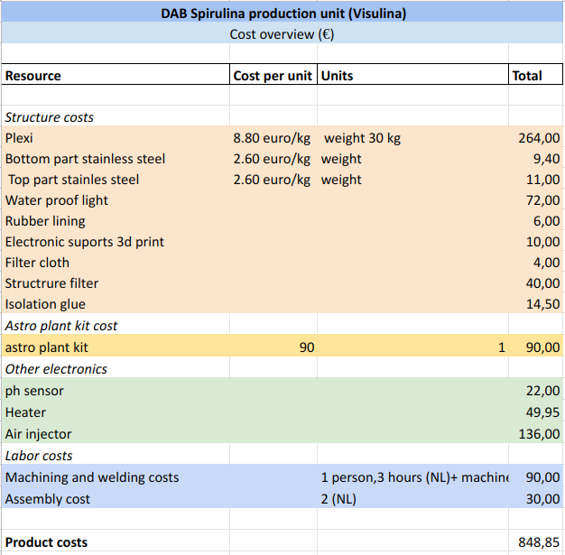

2. Spirulina market calculations

Dunga - 1,825 kg/year high-end market (Piccolo, 2011)
IIMSAM - 720 kg/year (Piccolo, 2011)
Galaxy - 1750g/day = 639 kg/year (Piccolo, 2011)
Thriving Green - thousands of litres, harvest every 25 days. Increase until it can supply 400 people (Eco Africa, 2018). Approx 60m3 * 4 = 240 m3 -> 240,000 litre (Bleisteiner, 2019).
Wet Spirulina biomass: 348g daily (Gammer, 2017)
Dry Spirulina powder: 34.8g daily (Gammer, 2017)
-> yearly production = 34.8 x 365 = 12,702 g = 12,7 kg/year
Tiwani - 1 acre production facility (Tiwani Spirulina, n.d.)
- Method 1. (Piccolo, 2011): 500 m2 can produce 25 days @ 5kg/day = 1500 kg/year. 1 acre = 4046.86m2. approx 75% Spirulina production -> 1500*6=9000kg/year
- Method 2. Double Dunga: Sold in the same stores as Dunga (Healthy-U store) and more. Double Dunga’s capacity = 3670 kg/year
- Wet Spirulina biomass: 115.7 daily (Gammer, 2017)
- Dry Spirulina powder: 11.57 daily = 4,223 kg/year (Gammer, 2017)

- Spirulico overview

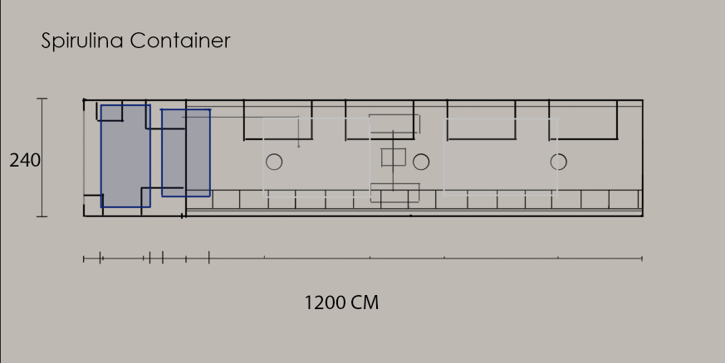

4. Kenya Spirulico production costs (links to all products available on request)

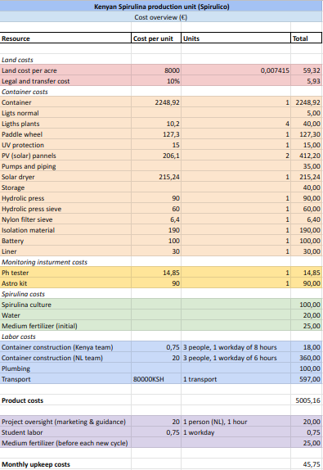

Bibliography

AgriFoodInnovation. (n.d.). Home. https://agrifoodinnovation.nl/
Alegbeleye, O. (2017). How Functional Is Moringa oleifera? A Review of Its Nutritive, Medicinal, and Socioeconomic Potential. Food And Nutrition Bulletin, 39(1), 149-170. doi: 10.1177/0379572117749814
Algae Research Supply (n.d.). Temperature of my algae culture. https://algaeresearchsupply.com/pages/should-i-heat-my-algae-culture
Algorin. (n.d.). How to recognize quality Spirulina. https://algorigin.com/en/algae/spirulina/spirulina-quality/
Allaguvatova, R., Myasina, Y., Zakharenko, V., & Gaysina, L. (2019). A simple method for the cultivation of algae Chlorella vulgaris Bejerinck. IOP Conference Series: Earth And Environmental Science, 390. doi: 10.1088/1755-1315/390/1/012020
Allgöwer, S. (2020). Kenya suffers from the worst locust infestation in 70 years. https://www.thriving-green.com/en/blog/kenia-leidet-unter-der-schlimmsten-heuschreckenplage-seit-70-jahren-1/
Alobwede, E., Leake, J. R., & Pandhal, J. (2019). Circular economy fertilization: Testing micro and macro algal species as soil improvers and nutrient sources for crop production in greenhouse and field conditions. Geoderma, 334, 113–123. https://doi.org/10.1016/j.geoderma.2018.07.049
Aswani, N. (2018). Fish Farming in Kenya Business Plan and Tips. Tuko. https://www.tuko.co.ke/263097-fish-farming-kenya-business-plan-tips.html
Aurospirul. (n.d.). Production Process. aurospirul.com. https://aurospirul.com/production-process.html
Bathmanathan, V., & Hironaka, C. (2016l). Sustainability and business: what is green corporate image?. IOP Conference Series: Earth and Environmental Science, 32(1), 012049. IOP Publishing Ltd.
Bennamoun, L., & Belhamri, A. (2003). Design and simulation of a solar dryer for agriculture products. Journal of Food Engineering, 59(2–3), 259–266. https://doi.org/10.1016/s0260-8774(02)00466-1
Bleisteiner, I. (2019). Construction of our new location in Ebukanga. https://www.thriving-green.com/en/blog/construction-new-location-ebukanga/
BusinessGreen. (2010). Voluntary Emission Reduction (VER). https://www.businessgreen.com/glossary/1803024/voluntary-emission-reduction-ver#:~:text=Voluntary%20Emission%20Reductions%20(VERs)%20are,as%20the%20Clean%20Development%20Mechanism
Chen, C.-Y., Kao, P.-C., Tsai, C.-J., Lee, D.-J., & Chang, J.-S. (2013). Engineering strategies for simultaneous enhancement of C-phycocyanin production and CO2 fixation with Spirulina platensis. Bioresource Technology, 145, 307–312. https://doi.org/10.1016/j.biortech.2013.01.054
Chuntapa, B., Powtongsook, S., & Menasveta, P. (2003). Water quality control using Spirulina platensis in shrimp culture tanks. Aquaculture, 220(1–4), 355–366. https://doi.org/10.1016/s0044-8486(02)00428-3
CIA. (n.d.). Kenya. https://www.cia.gov/library/publications/resources/the-world-factbook/geos/ke.html
DAB lab. (n.d.). Ondertekening Partners Delta Agrifood Business [video]. https://deltaagrifoodbusiness.nl/
Damodoran, A. (2021). Historical (Compounded Annual) Growth Rates by Sector. http://pages.stern.nyu.edu/~adamodar/New_Home_Page/datafile/histgr.html
De Farias Neves, F., Demarco, M., & Tribuzi, G. (2020). Drying and Quality of Microalgal Powders for Human Alimentation. Microalgae - From Physiology to Application, 1–20. https://doi.org/10.5772/intechopen.89324
Dining for women. (n.d.). Customs and cuisine of Kenya. https://diningforwomen.org/customsandcuisine/customs-and-cuisine-of-kenya/#:~:text=While%20different%20communities%20have%20their,ugali%2C%20sukuma%20wiki%20and%20githeri
Dunga Spirulina. (2011). Home Page. Retrieved from https://www.facebook.com/dungaspirulina/
Eco Africa. (2018). Spirulina, an algae superfood for Africa [Video]. Retrieved from https://www.dw.com/en/spirulina-an-algae-superfood-for-africa/av-42605287
ESA. (n.d.). AstroPlant: citizen science for growing plants in space. https://www.esa.int/Science_Exploration/Human_and_Robotic_Exploration/AstroPlant_citizen_science_for_growing_plants_in_space
Esilaba, F. A., Moturi, W. N., & Mokua, M. A. (2017). Urban consumers’ fish preferences and the determinants influencing fish selection and consumption: Case study of Nakuru Town, Kenya.
Fair Climate Fund. (n.d.). Van 30 euro tot 25 eurocent: de prijs van een ton CO2. https://www.fairclimatefund.nl/nieuws/van-30-eurocent-tot-25-euro-de-prijs-van-een-ton-co2
FAO. (2015). The Republic of Kenya. http://www.fao.org/fishery/facp/KEN/en
Foodvalley. (n.d.). Foodvalley NL. https://www.foodvalley.nl/our-team/foodvalley-nl/
Gill, R. (2011). An integrative review of storytelling: Using corporate stories to strengthen employee engagement and internal and external reputation. PRism, 8(1), 1-16.
Grahl, S., Strack, M., Weinrich, R., & Mörlein, D. (2018). Consumer-oriented product development: the conceptualization of novel food products based on Spirulina (arthrospira platensis) and resulting consumer expectations. Journal of Food Quality, 2018(12).
Grosshagauer, S., Kraemer, K., & Somoza, V. (2020). The True Value of Spirulina. Journal of Agricultural and Food Chemistry, 68(14), 4109–4115. https://doi.org/10.1021/acs.jafc.9b08251
Habib, Md & Hasan, M.. (2008). A Review on Culture, Production and Use of Spirulina as Food for Humans and Feed for Domestic Animals and Fish.
IEA. (n.d.). Kenya energy outlook. https://www.iea.org/articles/kenya-energy-outlook
IIMSAM. (2003). Intergovernmental Observer to the United Nations Economic and Social Council Under ECOSOC Resolution 2003/212. https://iimsam.org/
Ivers, L., Cullen, K., Freedberg, K., Block, S., Coates, J., & Webb, P. (2009). HIV/AIDS, Undernutrition, and Food Insecurity. Clinical Infectious Diseases, 49(7), 1096-1102. doi: 10.1086/605573
Jeurissen, S. M., Buurma-Rethans, E. J., Beukers, M. H., Jansen-van der Vliet, M., van Rossum, C. T., & Sprong, R. C. (2018). Consumption of plant food supplements in the Netherlands. Food & function, 9(1), 179-190.
Karanja Ng’ang’a, S., Bulte, E. H., Giller, K. E., McIntire, J. M., & Rufino, M. C. (2016). Migration and self-protection against climate change: a case study of Samburu County, Kenya. World Development, 84, 55-68.
KBV Research. (2019). LAMEA Spirulina Market Size, Share & Growth Report by 2025. https://www.kbvresearch.com/lamea-spirulina-market/
Kenya Power Care. (2021). Information about power outages by Kenya Power Care [Facebook page]. Facebook. https://www.facebook.com/KenyaPowerLtd/?hc_ref=ART1l5qdV2usF0TBSrF-BERJe8jbbSKFAZxSFUrmQ8wMO1RlinX0s8kRIK-2X8E19d4&fref=nf&__tn__=kC-R
Khan, Z., Bhadouria, P., & Bisen, P. S. (2005). Nutritional and therapeutic potential of Spirulina. Current pharmaceutical biotechnology, 6(5), 373-379.
Kimani-Murage, E. W., Muthuri, S. K., Oti, S. O., Mutua, M. K., van de Vijver, S., & Kyobutungi, C. (2015). Evidence of a double burden of malnutrition in urban poor settings in Nairobi, Kenya. PloS one, 10(6), e0129943.
Koyande, A., Chew, K., Rambabu, K., Tao, Y., Chu, D., & Show, P. (2019). Microalgae: A potential alternative to health supplementation for humans. Food Science And Human Wellness, 8(1), 16-24. doi: 10.1016/j.fshw.2019.03.001
Lupia, R., & Chien, S. (2012). HIV and AIDS Epidemic in Kenya: An Overview. Journal Of Experimental & Clinical Medicine, 4(4), 231-234. doi: 10.1016/j.jecm.2012.06.007
Madhlopa, A., & Ngwalo, G. (2007). Solar dryer with thermal storage and biomass-backup heater. Solar Energy, 81(4), 449–462. https://doi.org/10.1016/j.solener.2006.08.008
Mehar, J., Shekh, A., M. U., N., Sarada, R., Chauhan, V. S., & Mudliar, S. (2019). Automation of pilot-scale open raceway pond: A case study of CO2-fed pH control on Spirulina biomass, protein and phycocyanin production. Journal of CO2 Utilization, 33, 1–400. https://doi.org/10.1016/j.jcou.2019.07.006
Ministry of Health. (2011). The Kenya National Micronutrient Survey.
NAFTC. (2015). Abou Us. https://www.naftc.nl/aboutnaftc/
National Bureau of Statistics-Kenya and ICF International. 2015. 2014 KDHS Key Findings. Rockville, Maryland, USA: KNBS and ICF International.
Nitto. (n.d.). Nitto Japan (English) | TEMISHTM. https://www.nitto.com/eu/es/about_us/brand/promotion/innovation/temish.html#:%7E:text=The%20amazing%20sheet%20TEMISH%E2%84%A2,to%20children%20starts%20to%20move.
Obiero, K., Meulenbroek, P., Drexler, S., Dagne, A., Akoll, P., Odong, R., ... & Waidbacher, H. (2019). The contribution of fish to food and nutrition security in Eastern Africa: Emerging trends and future outlooks. Sustainability, 11(6), 1636.
Odeph, C. (2019). In denial? Middle class borrows to fund expensive lifestyle. https://nation.africa/kenya/business/in-denial-middle-class-borrows-to-fund-expensive-lifestyle-173830
Persistence Market Research. (2017). Spirulina Market. https://www.persistencemarketresearch.com/market-research/spirulina-market.asp
Piccolo, A. (2011). Spirulina, A Livelihood and A Business Venture. http://www.fao.org/3/a-az386e.pdf
Plecher, H. (2020). Unemployment rate in Kenya in 2020. https://www.statista.com/statistics/808608/unemployment-rate-in-kenya/#:~:text=Kenya%27s%20unemployment%20rate%20was%202.64,work%20but%20cannot%20find%20jobs
Plecher, H. (2020). Unemployment rate in the Netherlands 2020. https://www.statista.com/statistics/263703/unemployment-rate-in-the-netherlands/
Rothuis, A., M. Turenhout, A. van Duijn, A. Roem, E. Rurangwa, E. Katunzi, A. Shoko & J. B. Kabagambe. (2014). Aquaculture in East Africa; A regional approach. LEI Wageningen University & Research.
Rothuis, A.J. & Turenhout, M.N.J. & van Duijn, Arie Pieter & Roem, Arjen & Rurangwa, Eugene & Katunzi, E.F.B. & Shoko, Amon & Kabagambe, J.B.. (2014). Aquaculture in East Africa : a regional approach.
Salaryexplorer. (n.d.). Average salary in Kenya 2021. Salary Explorer | Salary and Cost of Living Comparison. https://www.salaryexplorer.com/salary-survey.php?loc=111&loctype=1#:~:text=A%20person%20working%20in%20Kenya%20typically%20earns%20around%20147%2C000%20KES,%2C%20transport%2C%2
Sumant, O., & Kunsel, T. (2019). Spirulina Market Size and Share | Industry Forecast By 2019. https://www.alliedmarketresearch.com/spirulina-market
Tacoli, C., & Vorley, B. (2016). Informal food systems and food security in rural and urban East Africa. IIED Briefing Paper-International Institute for Environment and Development, (17336).
Taneja, J. (2017). Measuring Electricity Reliability in Kenya. https://blogs.umass.edu/jtaneja/files/2017/05/outages.pdf
Techleap. (n.d.). Home. https://www.techleap.nl/
Thriving Green. (n.d.). Home. https://www.thriving-green.com/en/
Tiwani Spirulina. (n.d.). Products. http://www.tiwanispirulina.com/store/c1/Featured_Products.html
United Nations. (n.d.). Goal 12. Department of Economic and Social Affairs. https://sdgs.un.org/goals/goal12
United Nations. (n.d.). Goal 2. Department of Economic and Social Affairs. https://sdgs.un.org/goals/goal2
United Nations. (n.d.). Goal 8. Department of Economic and Social Affairs. https://sdgs.un.org/goals/goal8
USDA. (2018). Fish, Tilapia, Raw. https://fdc.nal.usda.gov/fdc-app.html#/food-details/175176/nutrients
Van Hoof, L., & Steins, N. A. (2017). Mission report Kenya: Scoping mission marine fisheries Kenya (No. C038/17). Wageningen Marine Research.
Van Loon, E. (2021, 19.01.). Personal Interview.
Vernier. (n.d.). Can I place the CO2 sensor into a water sample? Does your CO2 sensor measure dissolved CO2? Do you have a dissolved CO2 sensor? https://www.vernier.com/til/2567
Wagner, J., Hinton, L., Mccordic, C., Owuor, S., Capron, G., & Arellano, S. G. (2019). Urban Food Deserts in Nairobi and Mexico City. https://hungrycities.net/wp-content/uploads/2019/02/DP28.pdf
Water Resources Authority. (2018). Water Resources Situation Report. https://wra.go.ke/wp-content/uploads/2019/07/National-Water-Situation-Report_2017-18.pdf
WHO. (2000). Feeding and nutrition of infants and young children. https://www.euro.who.int/__data/assets/pdf_file/0004/98302/WS_115_2000FE.pdf
World Bank. (2014). Kenyans Earn First Ever Carbon Credits From Sustainable Farming. https://www.worldbank.org/en/news/press-release/2014/01/21/kenyans-earn-first-ever-carbon-credits-from-sustainable-farming
Xe.com. (2021). Convert KES to USD. Retrieved January 16, 2021, from https://www.xe.com/
Yamane, T., & Kaneko, S. (2021). Is the Younger Generation a Driving Force Toward Achieving the Sustainable Development Goals? Survey Experiments. Journal of Cleaner Production, 125932.
宋.伟.国., 夏.增.光., 王.耀.朋., 刘.彬., & 夏.艳. (2014). Spirulina drying method (CN201310154302.XA). Worldwide applications. https://patents.google.com/patent/CN103519322A/en

As of January 2020, the DAB lab has become privatized, and is thus allowed to become a for-profit organization.
Low height for age

